# Synthesis Pathways

## Product 1

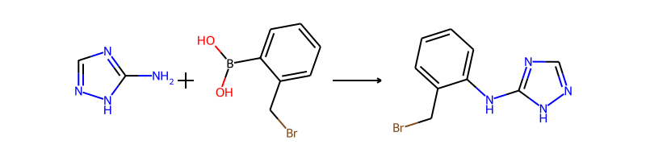

## Product 2

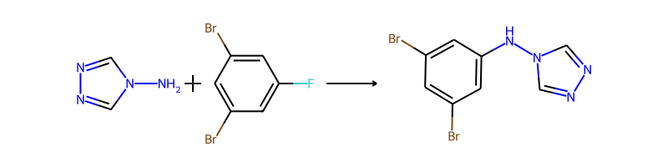

## Product 3

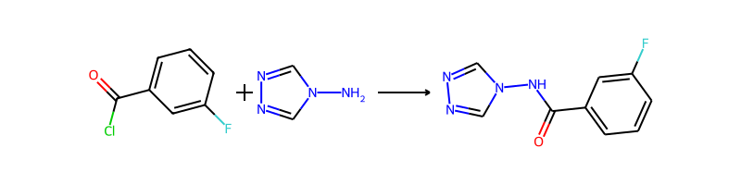

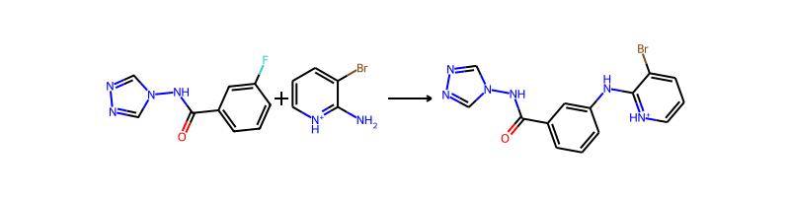

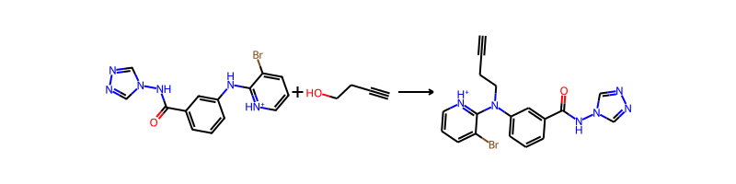

## Product 4

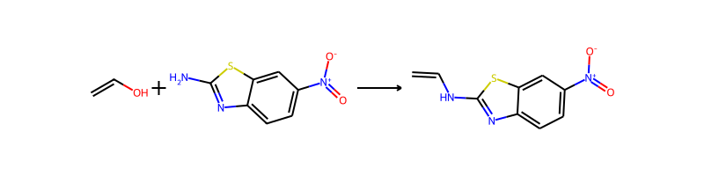

## Product 5

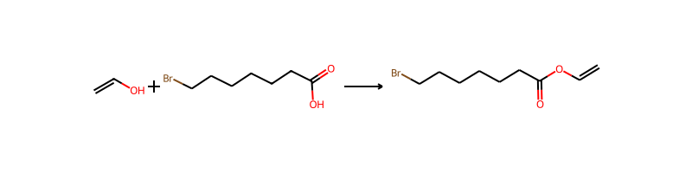

## Product 6

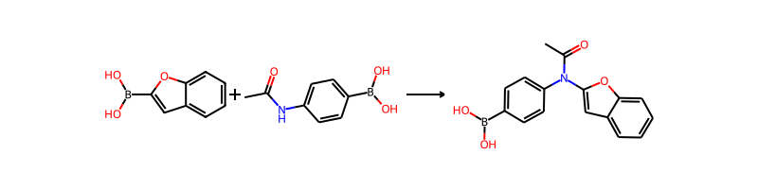

## Product 7

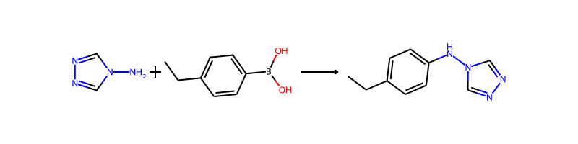

## Product 8

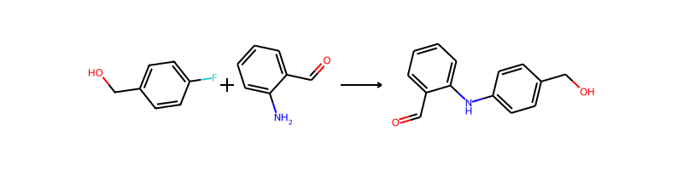

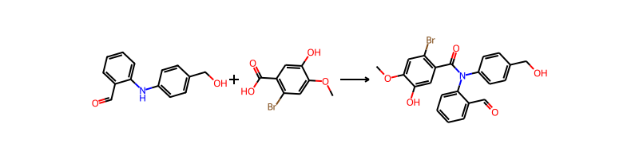

## Product 9

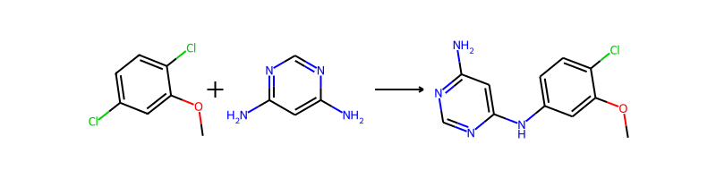

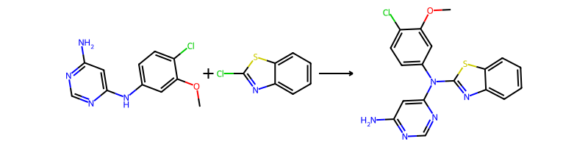

## Product 10

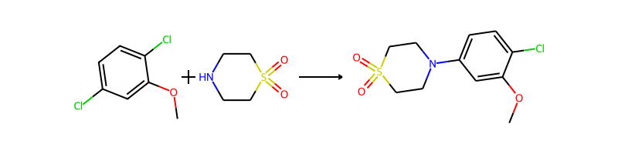

## Product 11



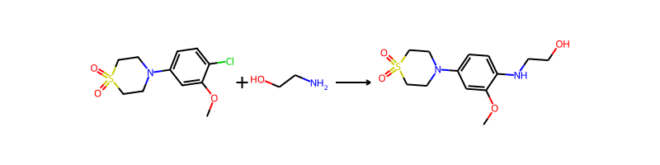

## Product 12

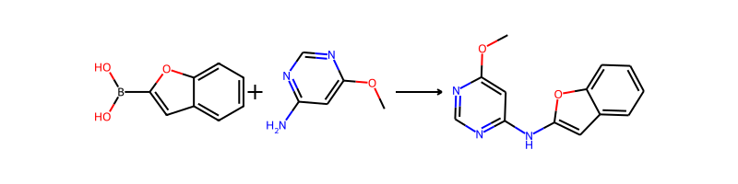

## Product 13

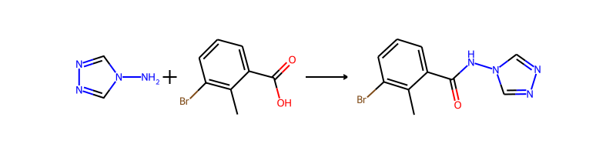

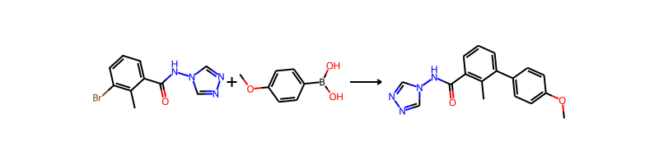

## Product 14

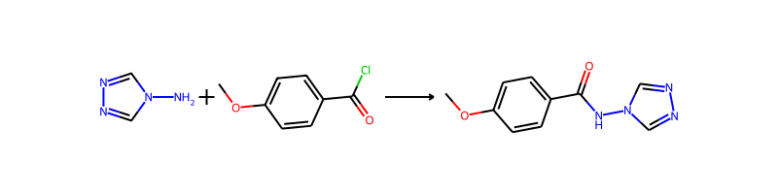

## Product 15

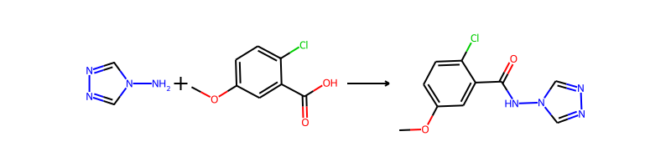

## Product 16

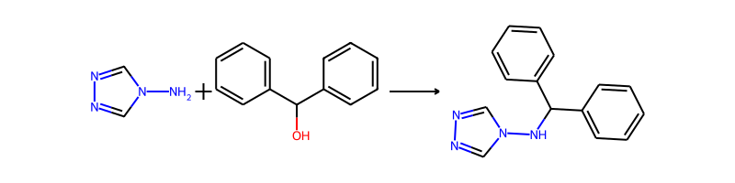

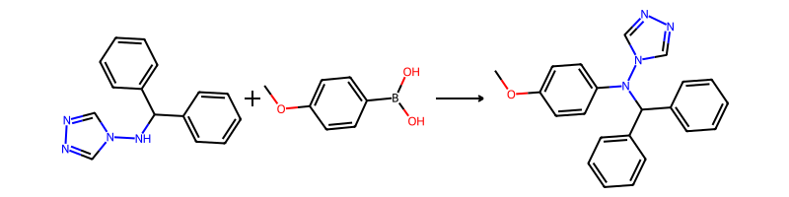

## Product 17

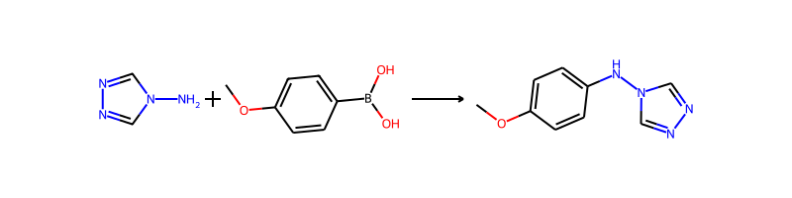

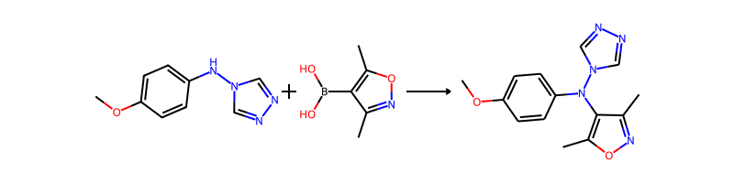

## Product 18

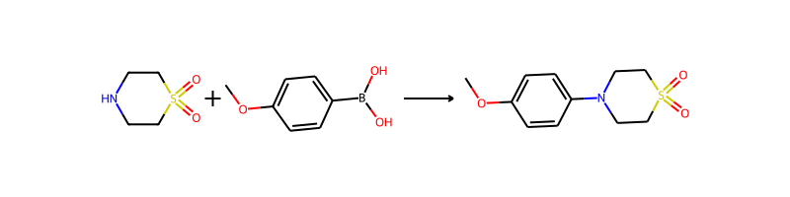

## Product 19



## Product 20

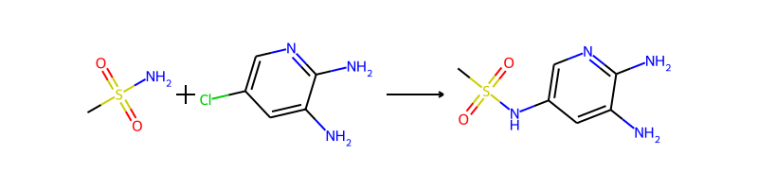

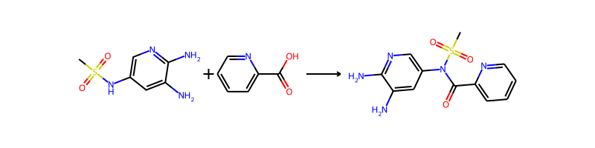

## Product 21

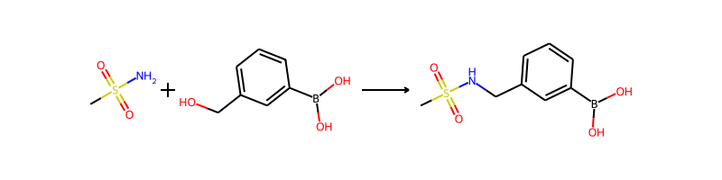

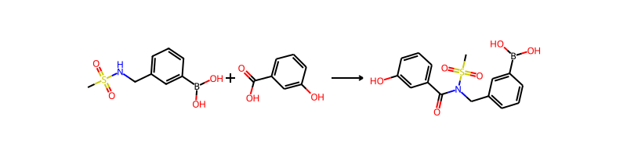

## Product 22

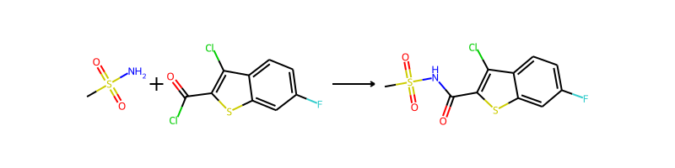

## Product 23

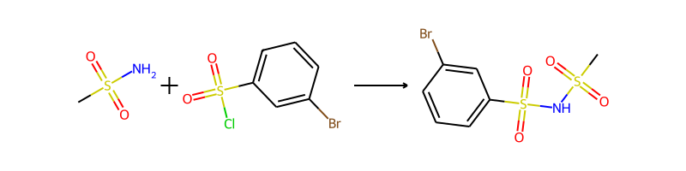

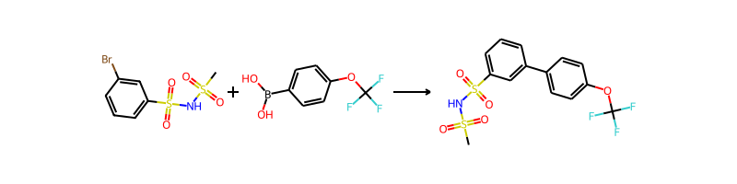

## Product 24

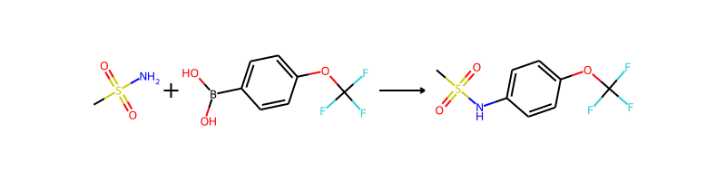

## Product 25

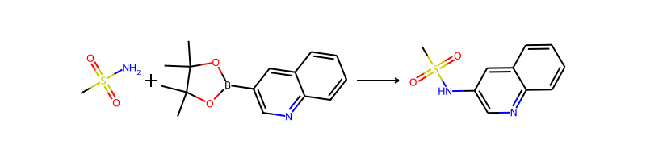

## Product 26



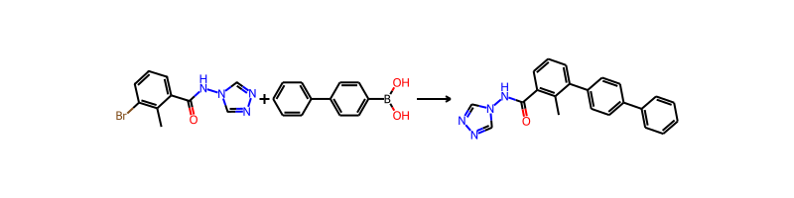

## Product 27



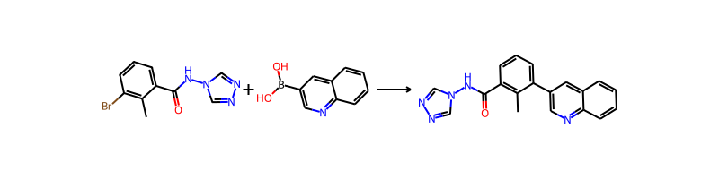

## Product 28

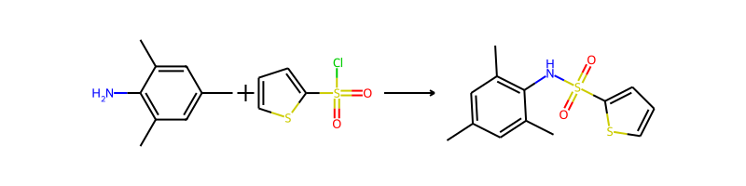

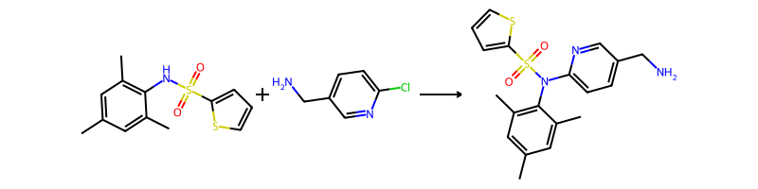

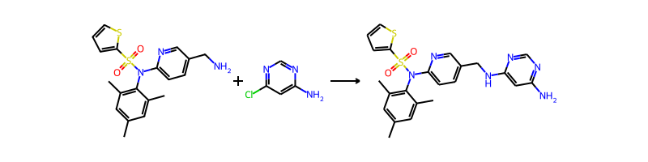

## Product 29

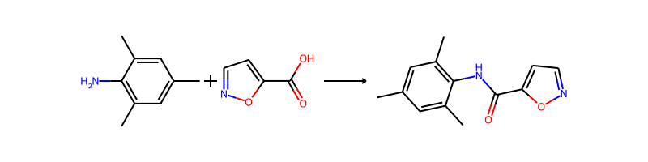

## Product 30

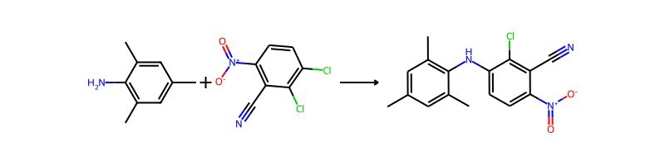

## Product 31

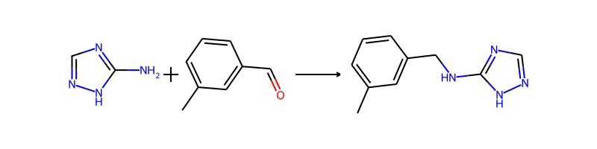

## Product 32

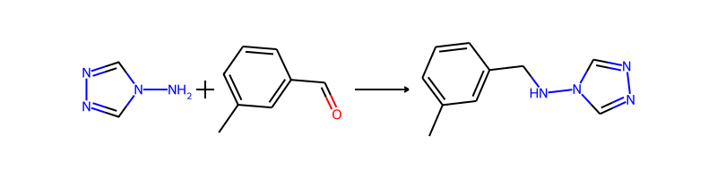

## Product 33

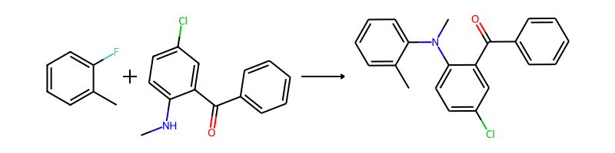

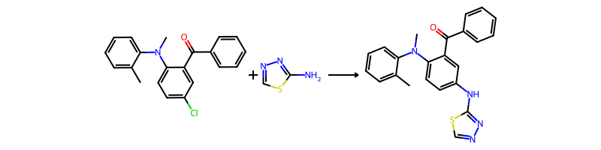

## Product 34

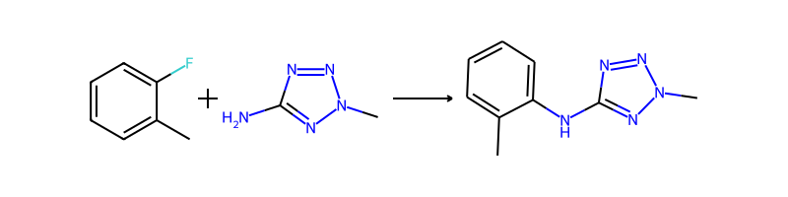

## Product 35

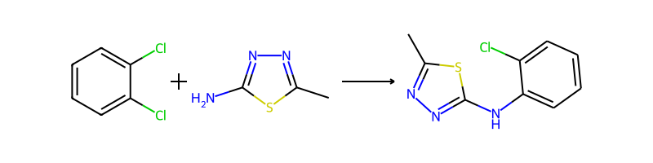

## Product 36

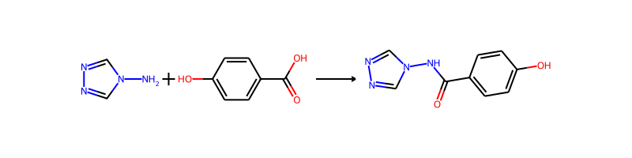

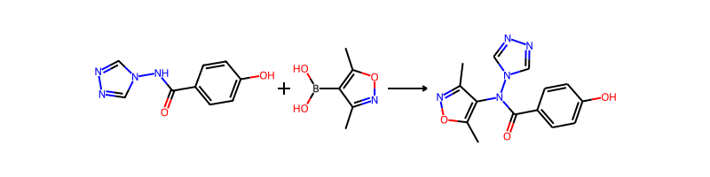

## Product 37

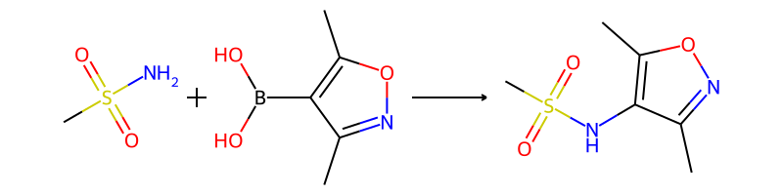

## Product 38

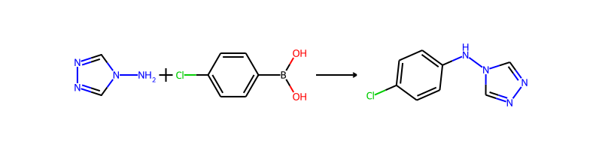

## Product 39

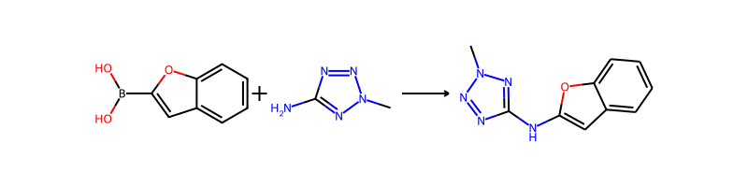

## Product 40

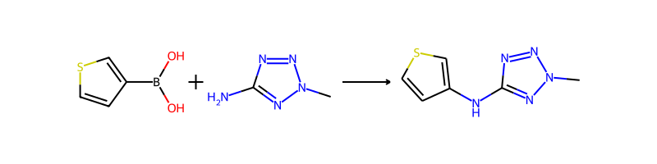

## Product 41

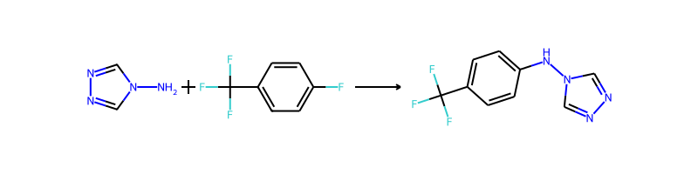

## Product 42

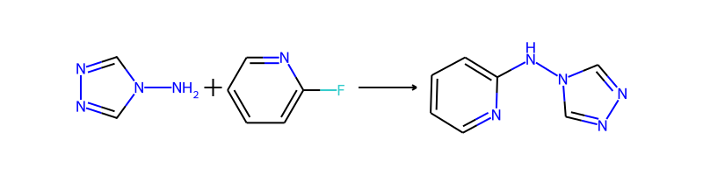

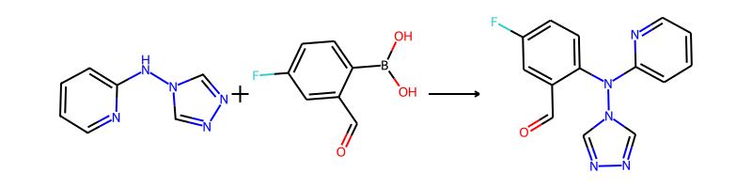

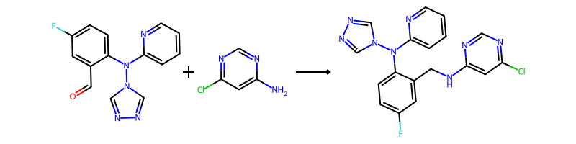

## Product 43

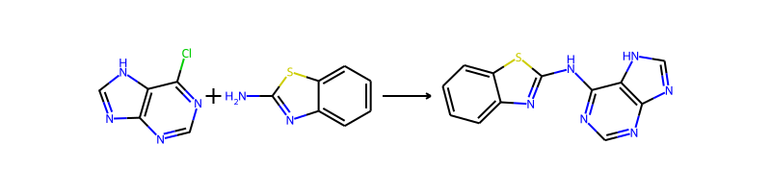

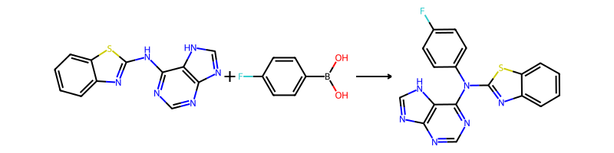

## Product 44

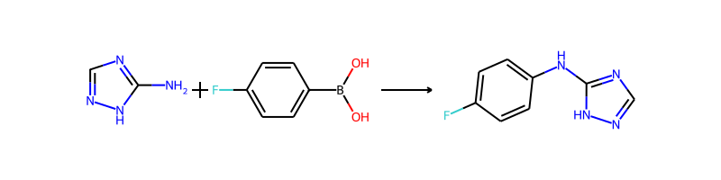

## Product 45

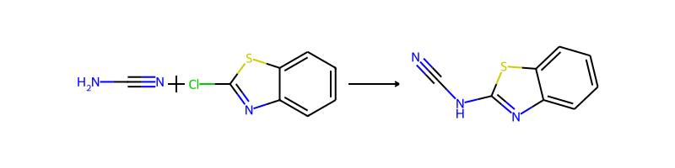

## Product 46

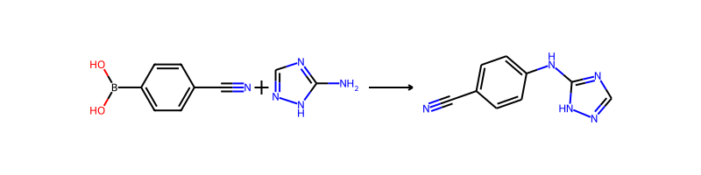

## Product 47

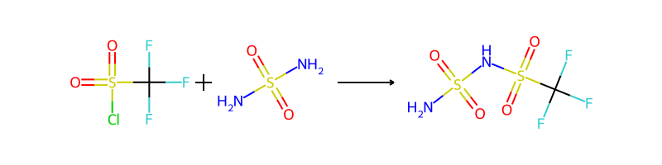

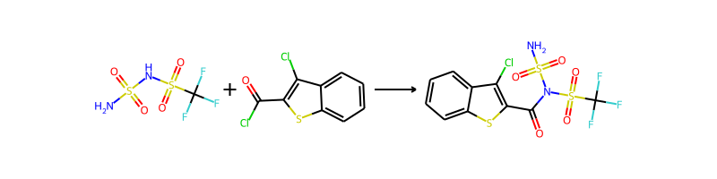

## Product 48

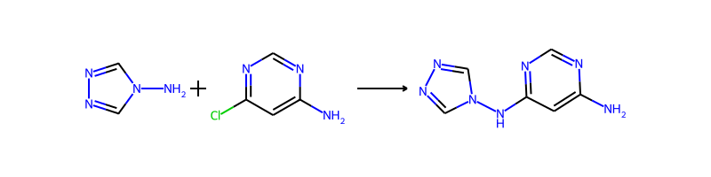

## Product 49

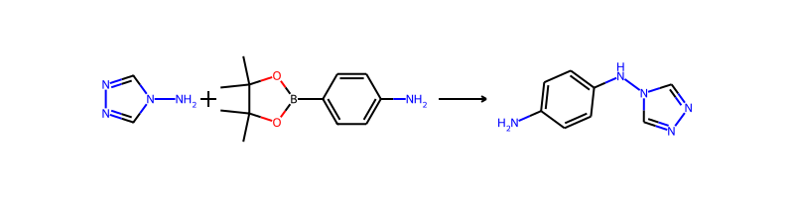

## Product 50

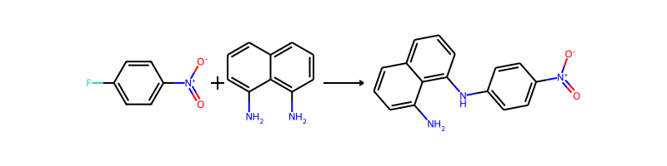

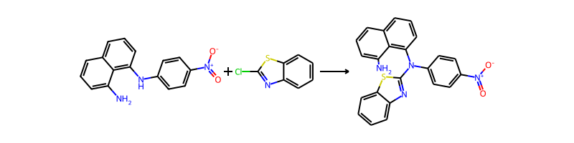

## Product 51

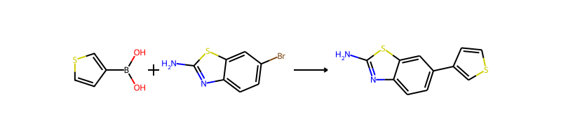

## Product 52

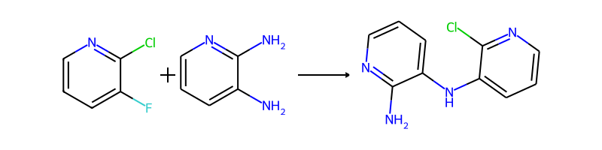

## Product 53



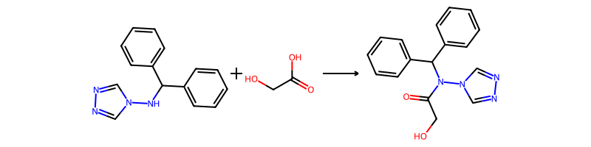

## Product 54

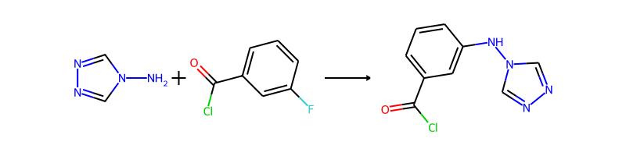

## Product 55

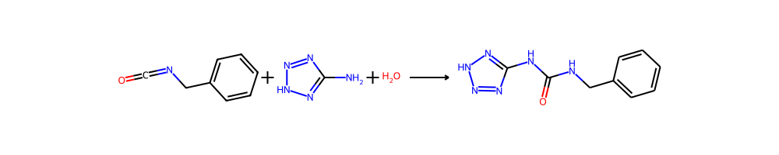

## Product 56

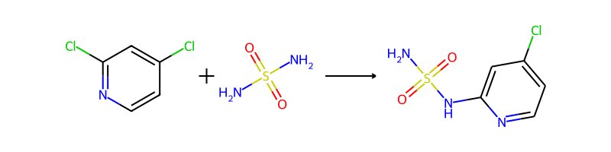

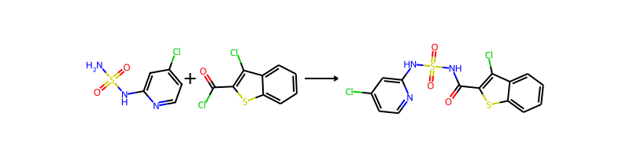

## Product 57

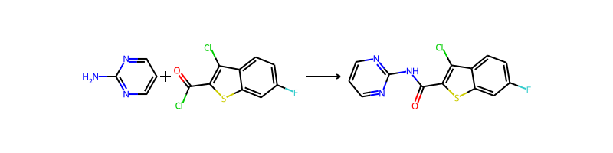

## Product 58

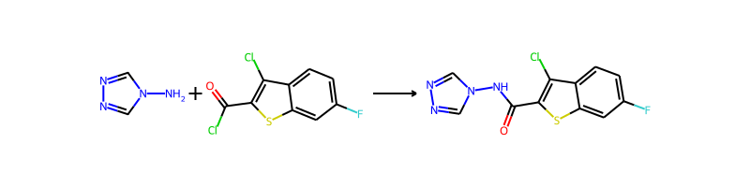

## Product 59

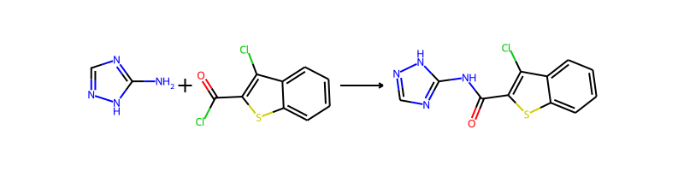

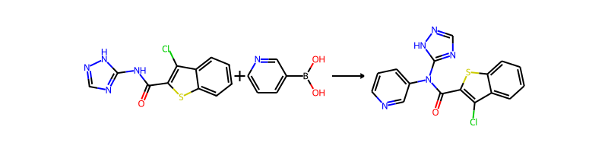

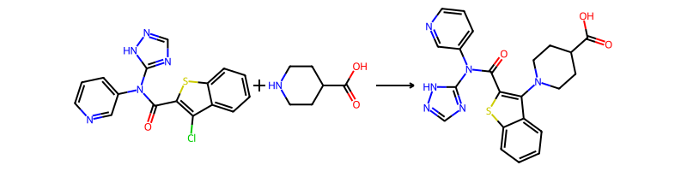

## Product 60

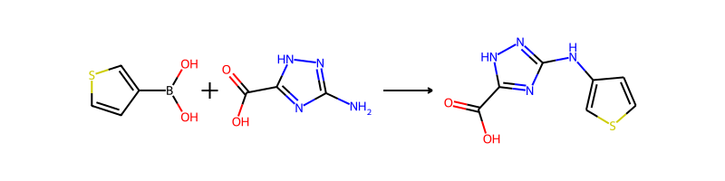

## Product 61

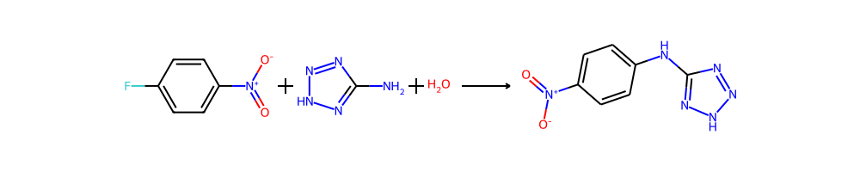

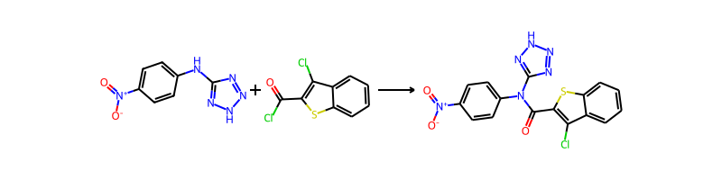

## Product 62

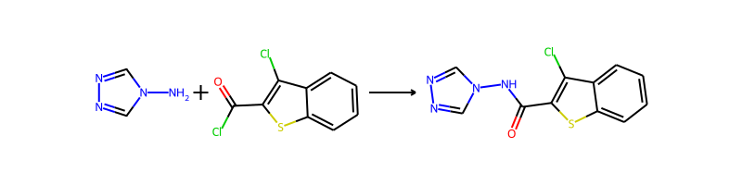

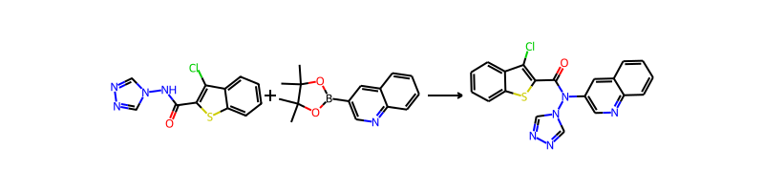

## Product 63

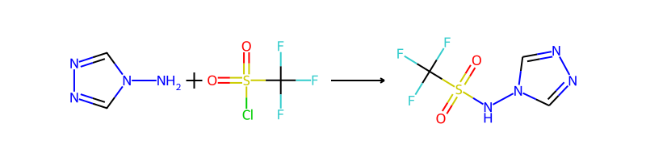

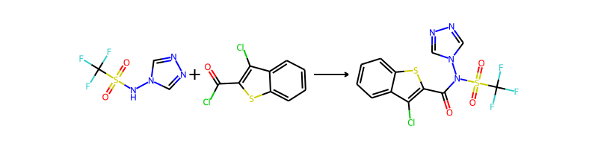

## Product 64

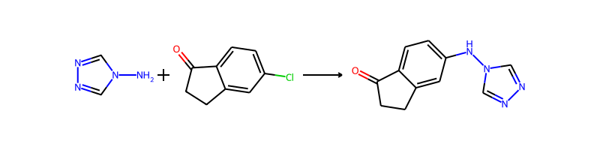

## Product 65

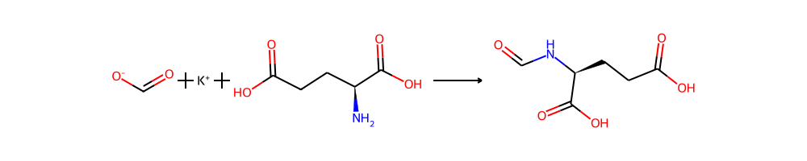

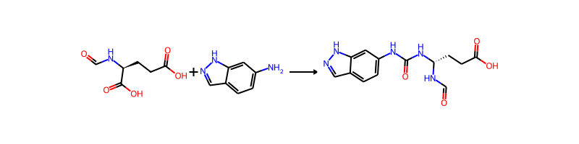

## Product 66

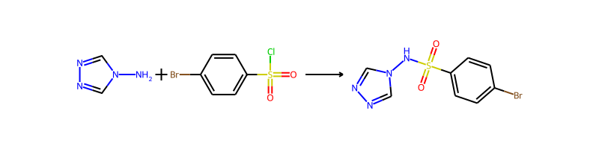

## Product 67

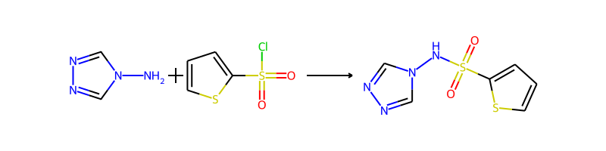

## Product 68

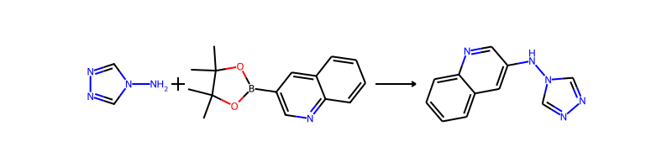

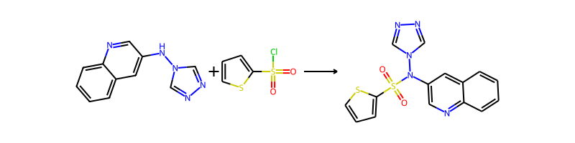

## Product 69

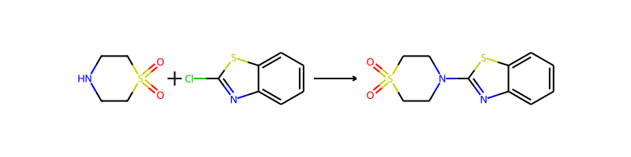

## Product 70

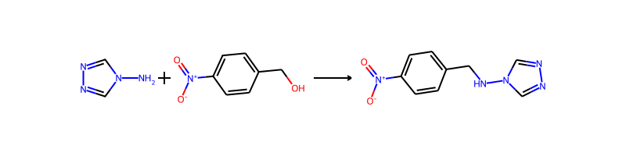

## Product 71

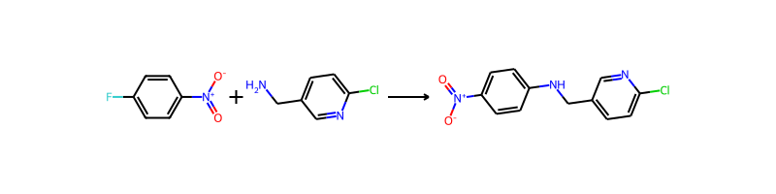

## Product 72

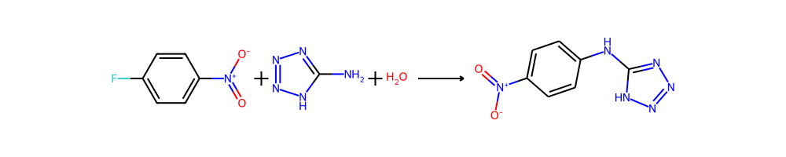

## Product 73

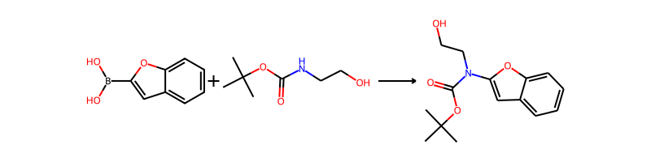

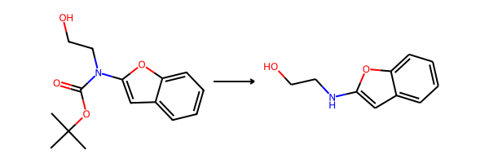

## Product 74

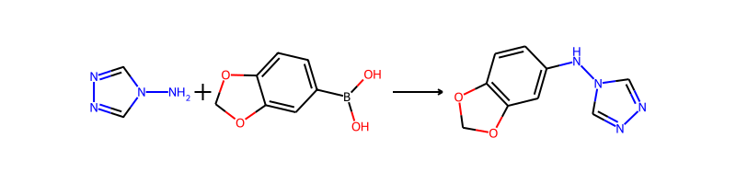

## Product 75

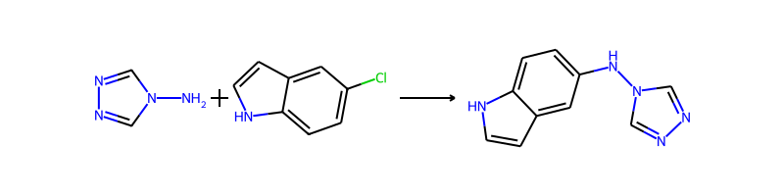

## Product 76

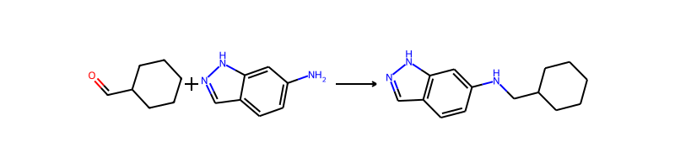

## Product 77

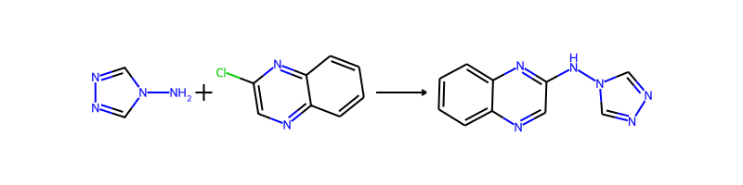

## Product 78

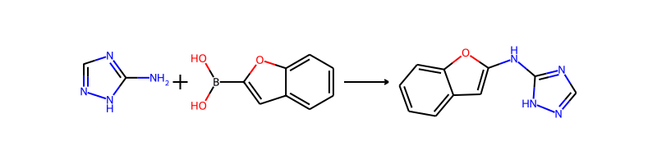

## Product 79

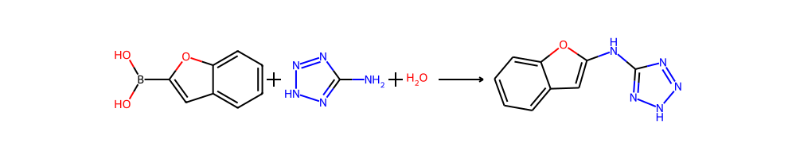

## Product 80

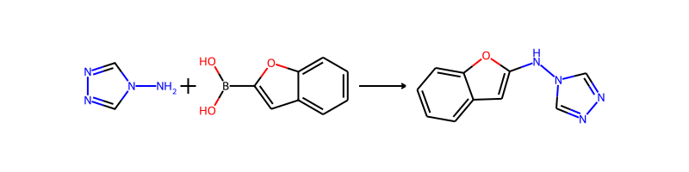

## Product 81

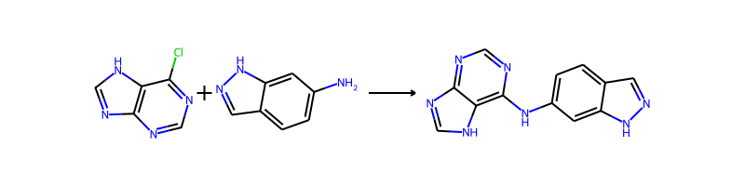

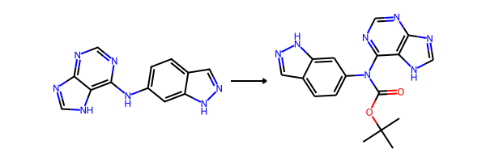

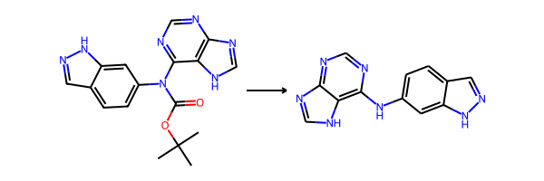

## Product 82

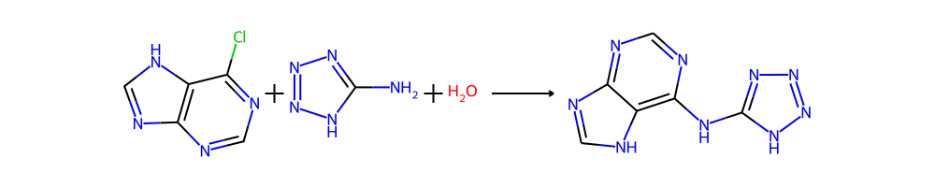

## Product 83

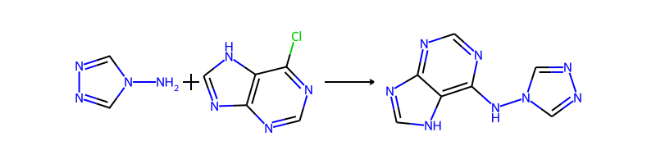

## Product 84

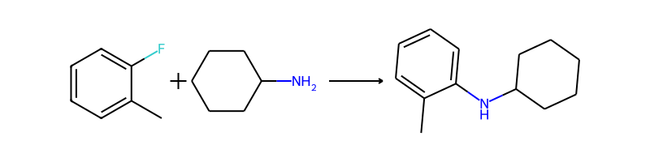

## Product 85

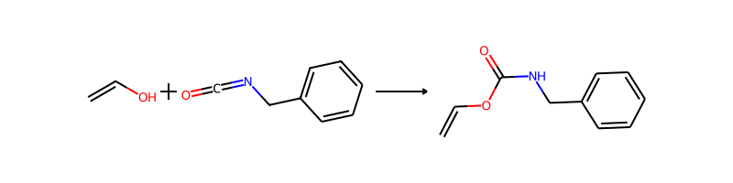

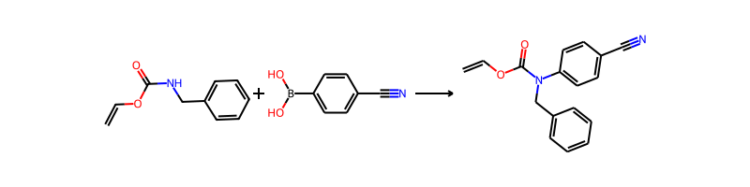

## Product 86

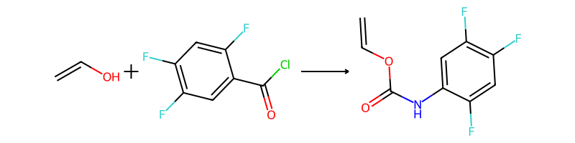

## Product 87

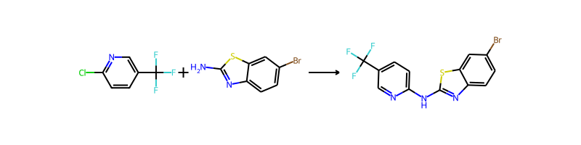

## Product 88

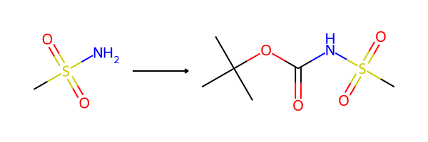

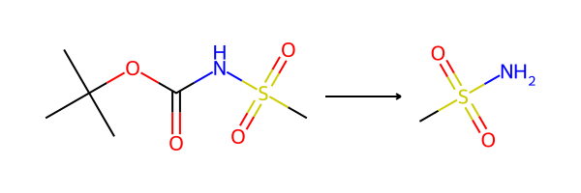

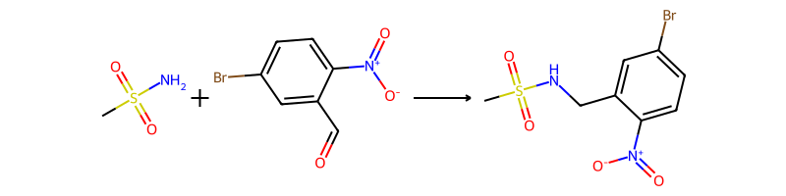

## Product 89

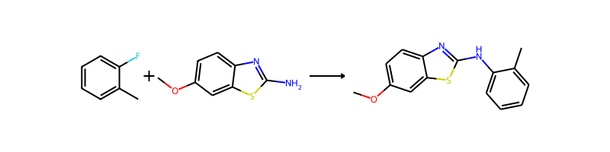

## Product 90

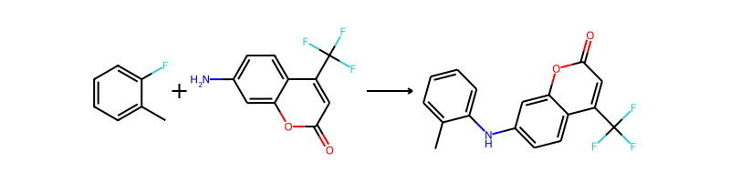

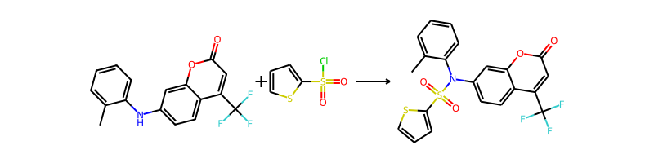

## Product 91

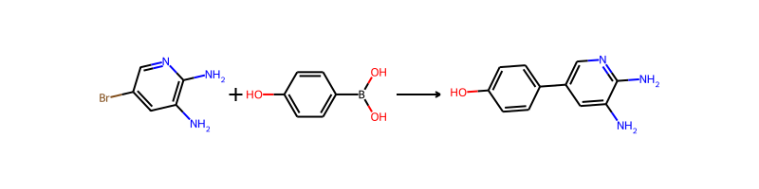

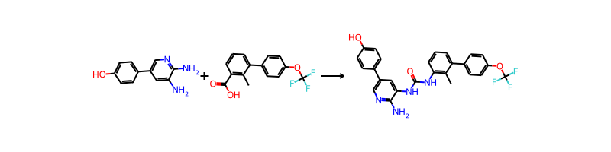

## Product 92



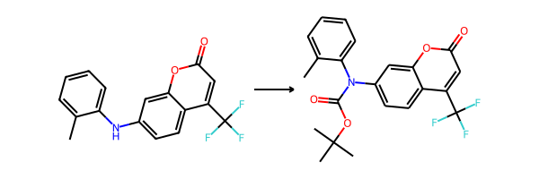

## Product 93



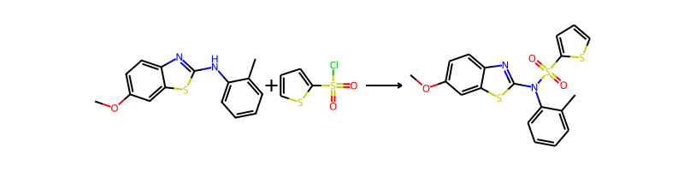

## Product 94

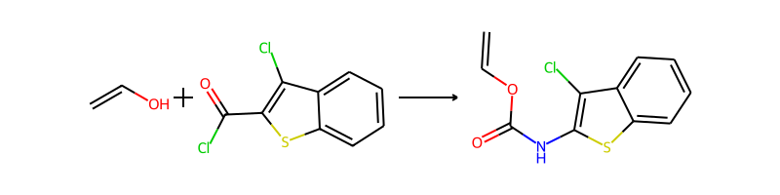

## Product 95

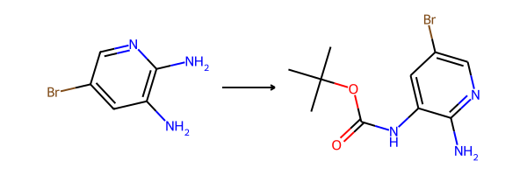

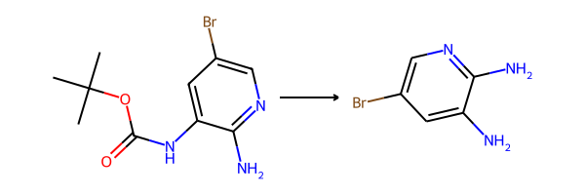

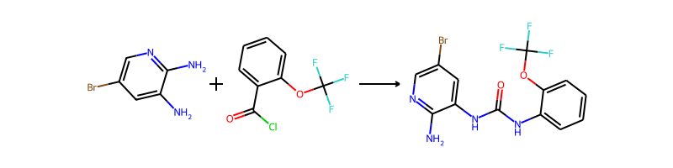

## Product 96

C1=C(C=NC(=C1N)N)Br.OB(O)c1ccc(Cl)cc1>>Nc1cc(-c2ccc(Cl)cc2)cnc1N

Nc1cc(-c2ccc(Cl)cc2)cnc1N.CCC/C=C/C=O>>CCC/C=C/CNc1cc(-c2ccc(Cl)cc2)cnc1N

CCC/C=C/CNc1cc(-c2ccc(Cl)cc2)cnc1N.COc1ccc(B(O)O)cc1OC>>CCC/C=C/CN(c1ccc(OC)c(OC)c1)c1cc(-c2ccc(Cl)cc2)cnc1N

## Product 97



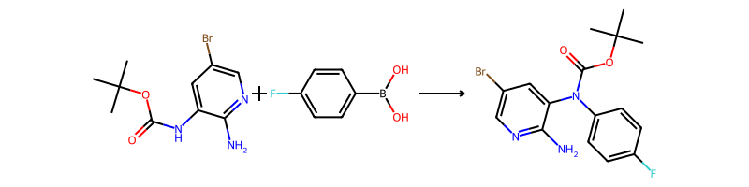

## Product 98



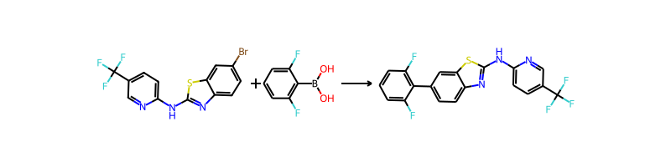

## Product 99

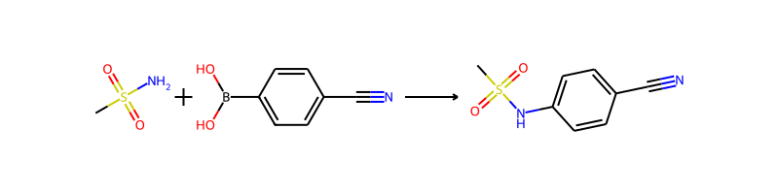

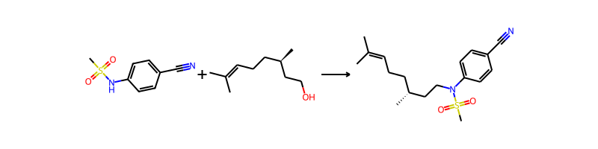

## Product 100

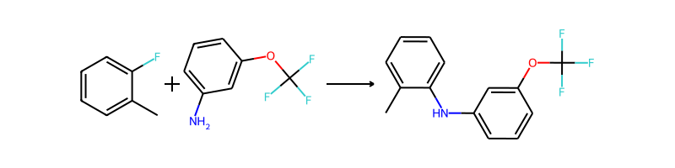

## Product 101

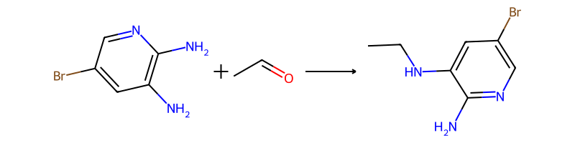

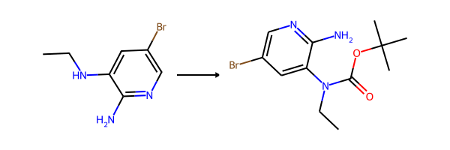

## Product 102

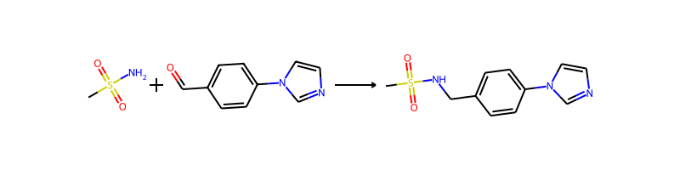

## Product 103

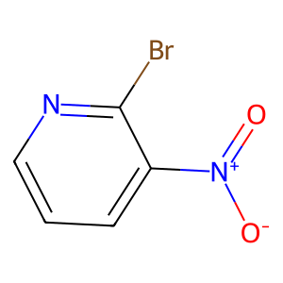

## Product 104

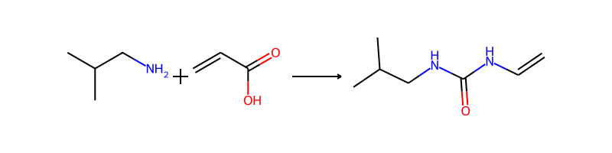

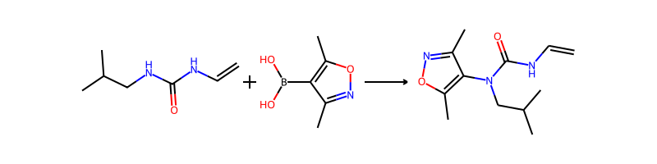

## Product 105



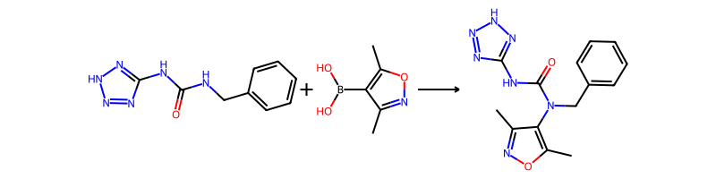

## Product 106

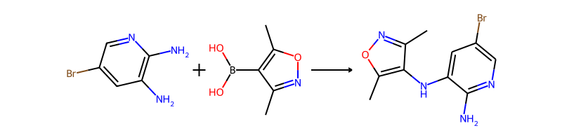

## Product 107

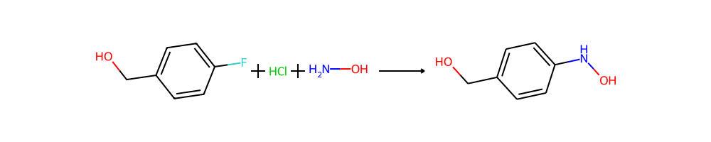

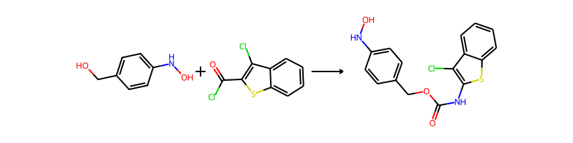

## Product 108

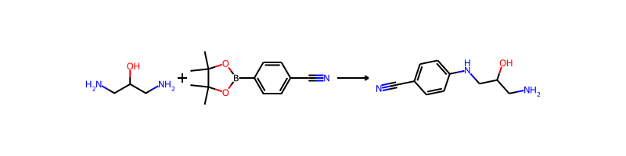

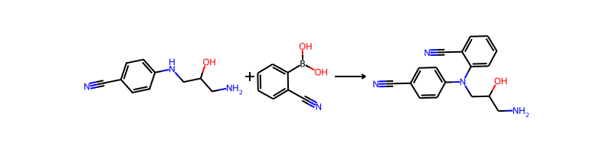

## Product 109

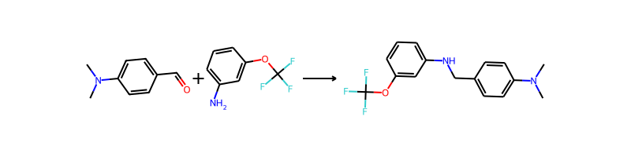

## Product 110

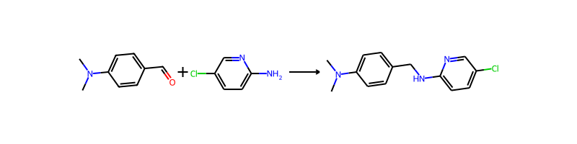

## Product 111

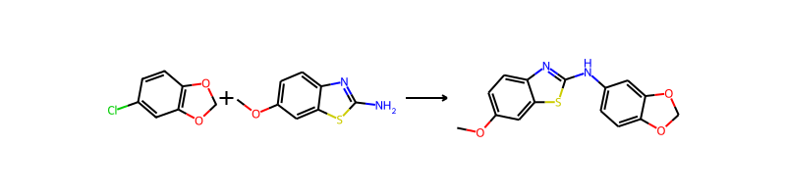

## Product 112

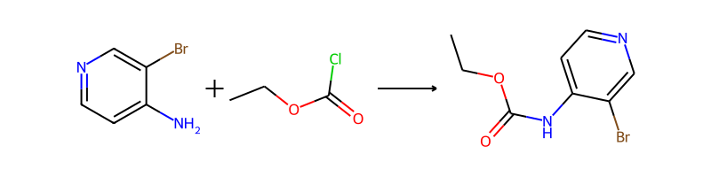

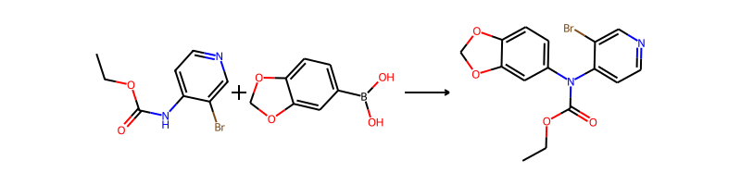

## Product 113

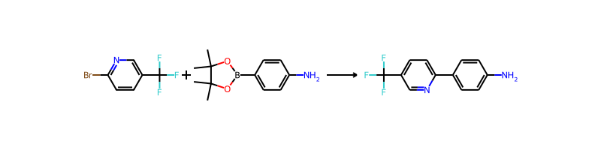

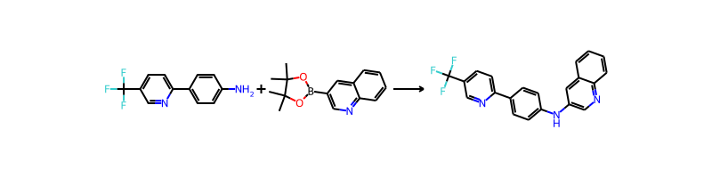

## Product 114

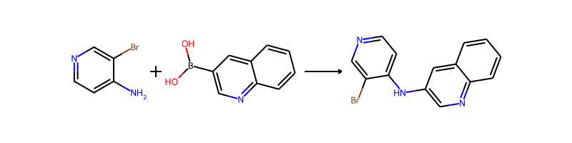

## Product 115

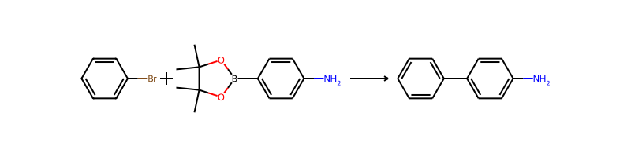

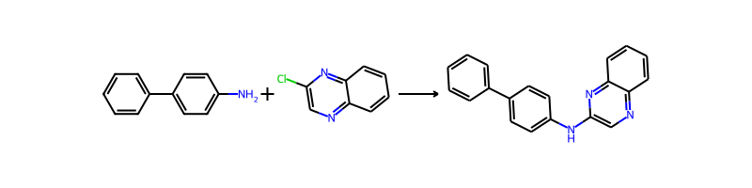

## Product 116

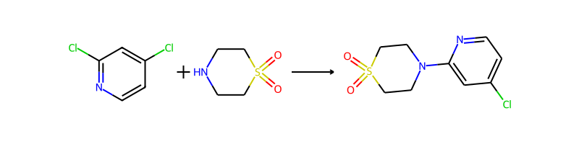

## Product 117



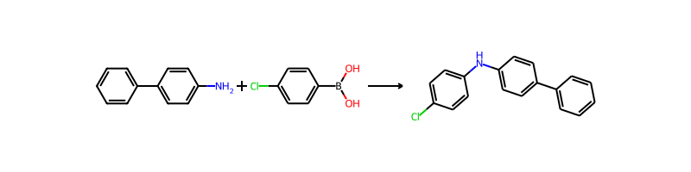

## Product 118

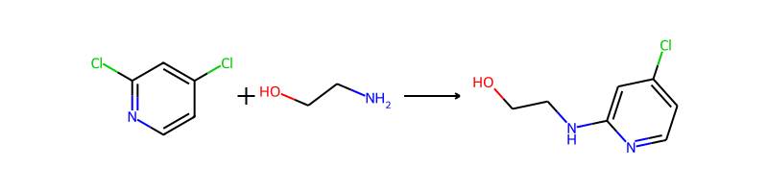

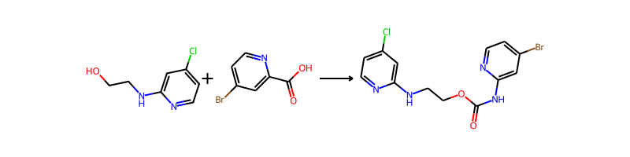

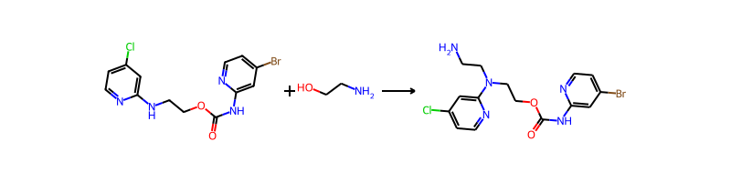

## Product 119





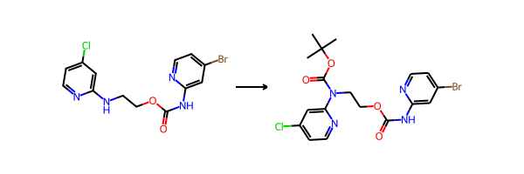

## Product 120

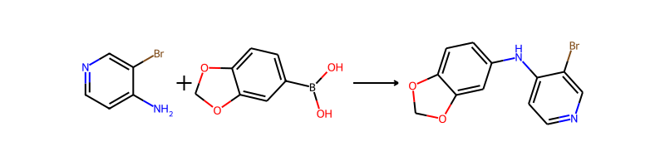

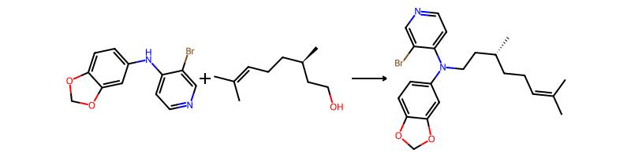

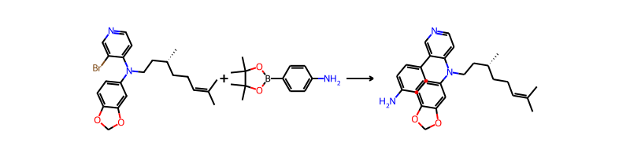

## Product 121

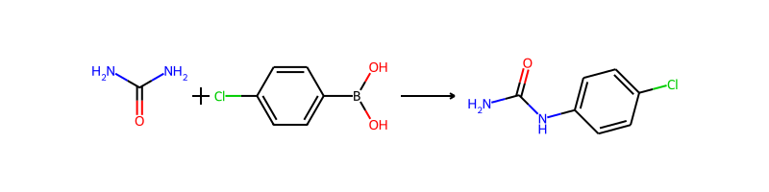

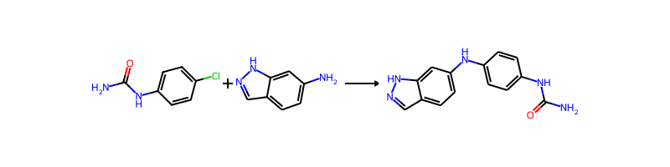

## Product 122

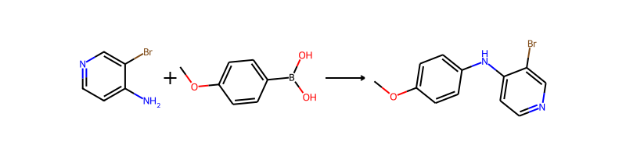

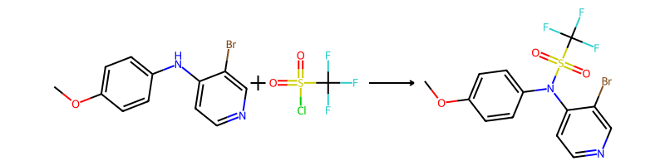

## Product 123

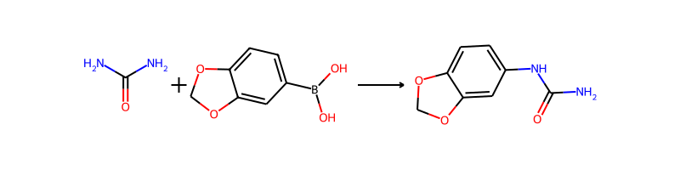

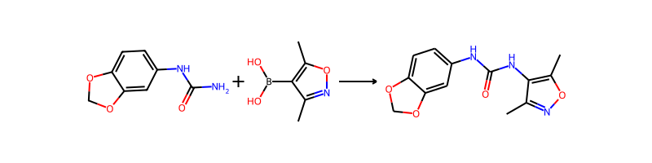

## Product 124



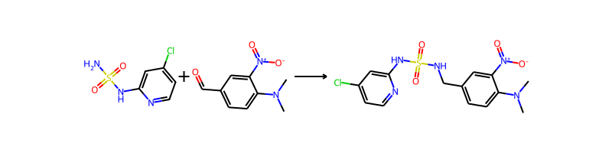

## Product 125



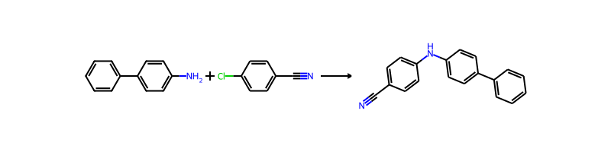

## Product 126





## Product 127

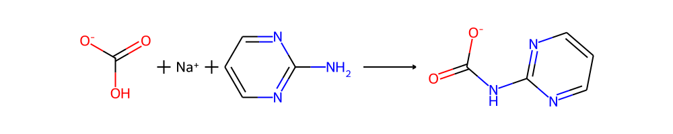

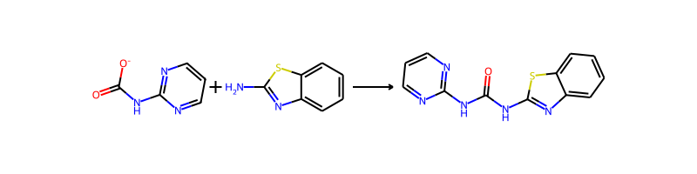

## Product 128

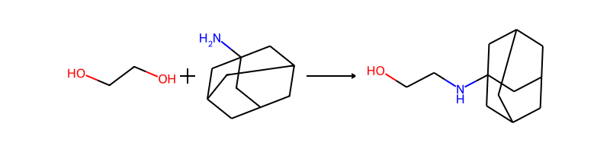

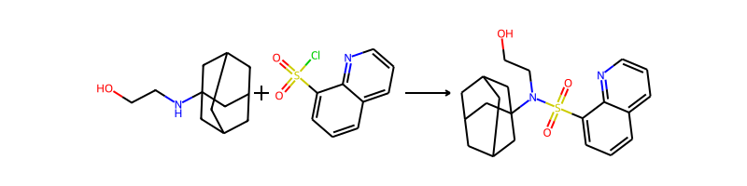

## Product 129

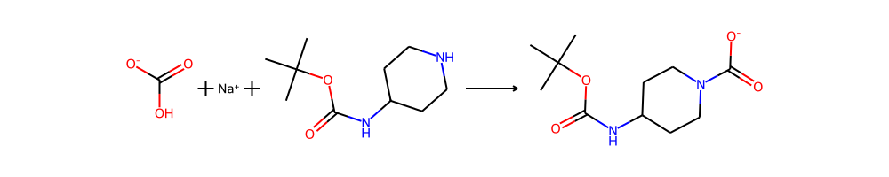

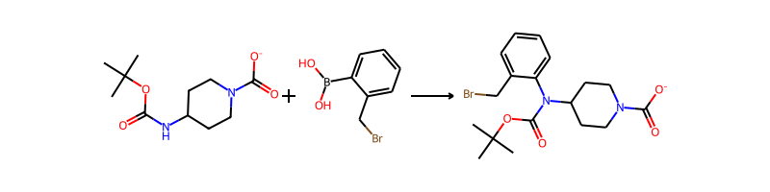

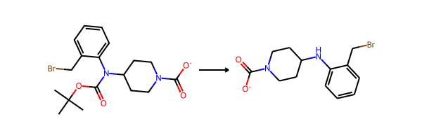

## Product 130

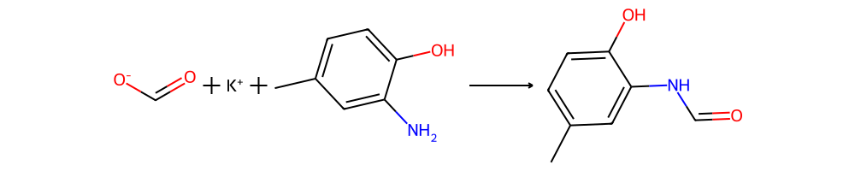

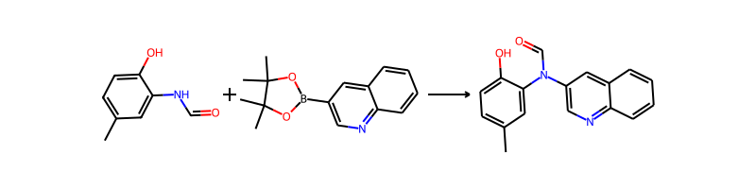

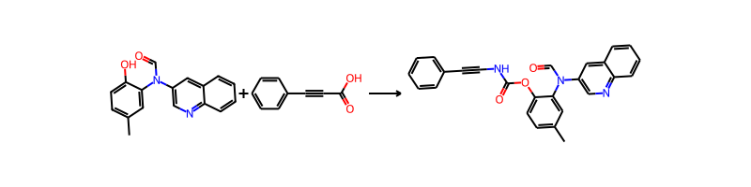

## Product 131

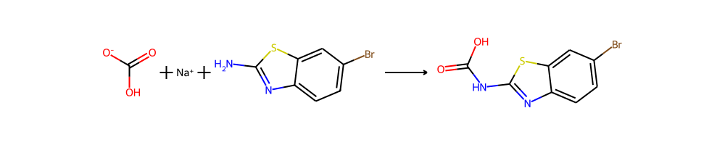

## Product 132

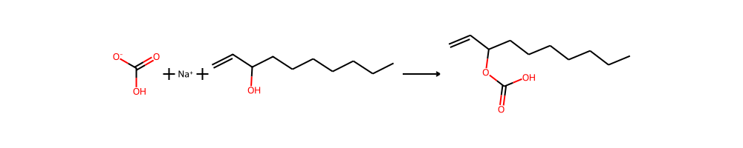

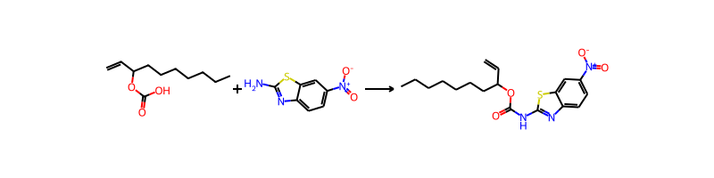

## Product 133



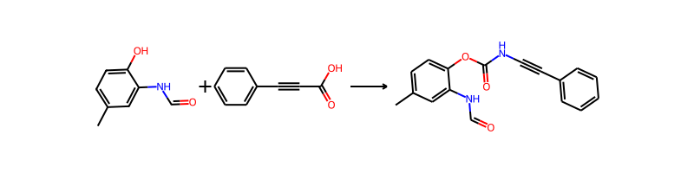

## Product 134

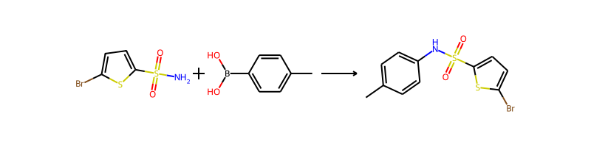

## Product 135



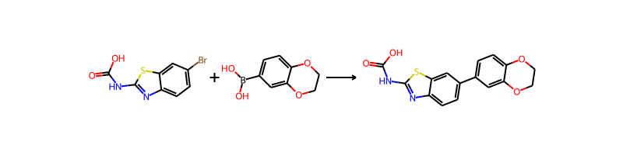

## Product 136

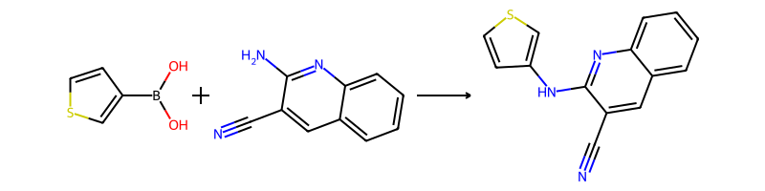

## Product 137

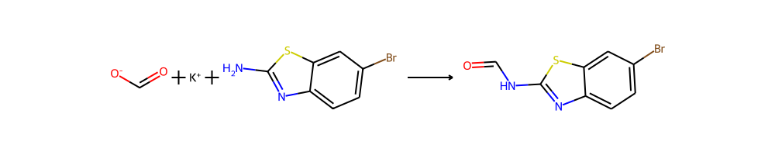

## Product 138

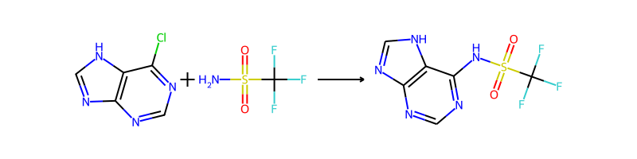

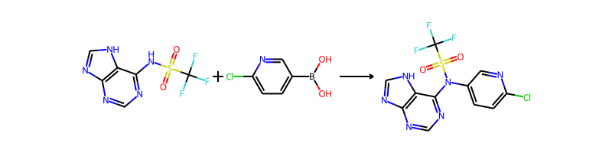

## Product 139



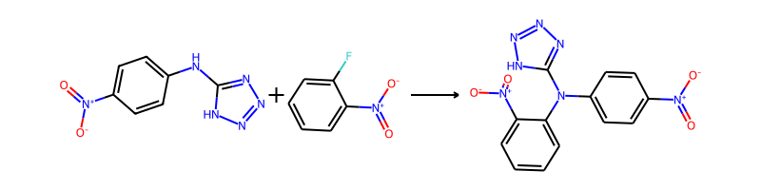

## Product 140

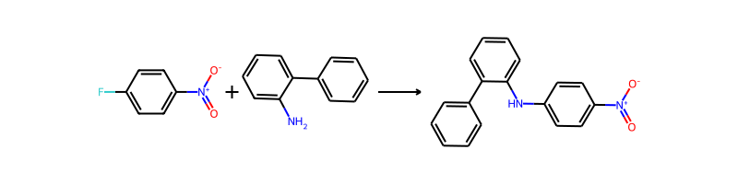

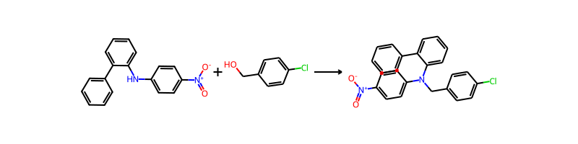

## Product 141

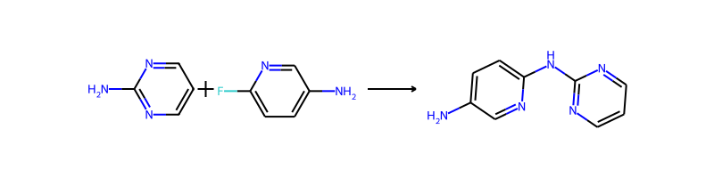

## Product 142



## Product 143

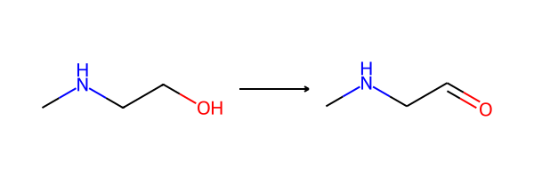

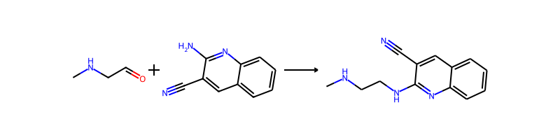

## Product 144

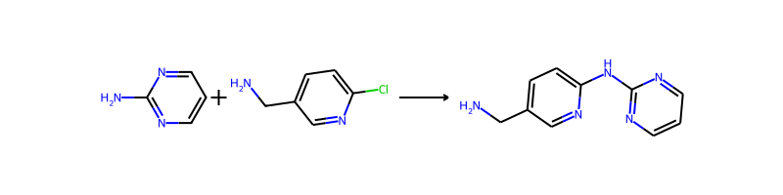

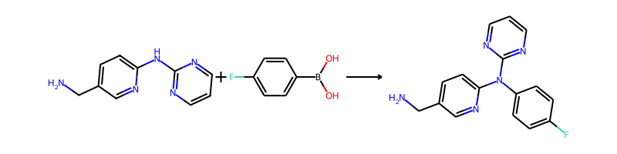

## Product 145

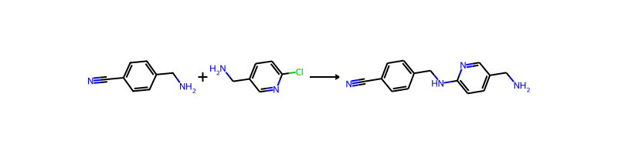

## Product 146

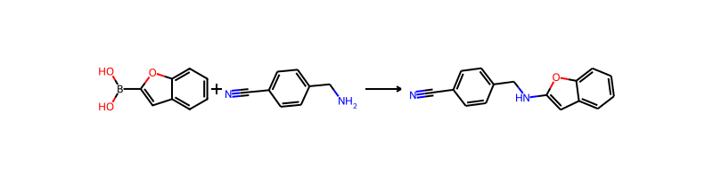

## Product 147

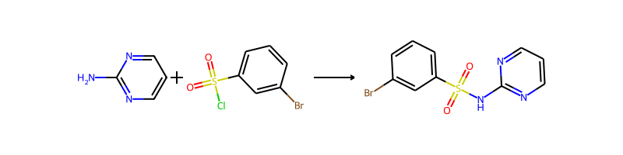

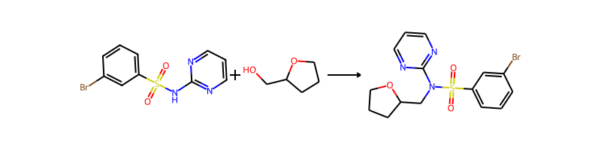

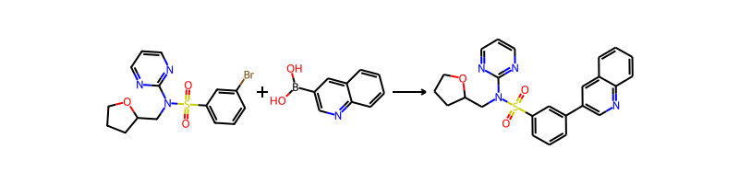

## Product 148

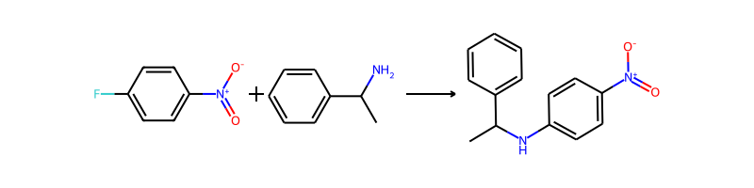

## Product 149

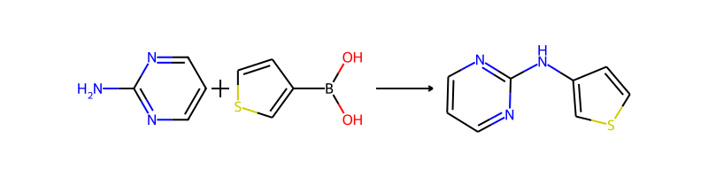

## Product 150

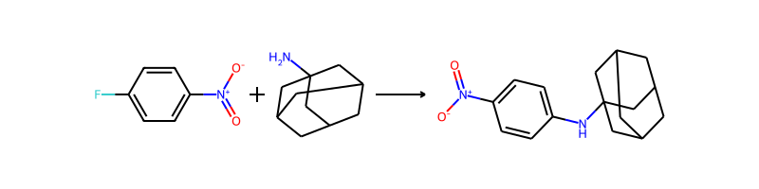

## Product 151

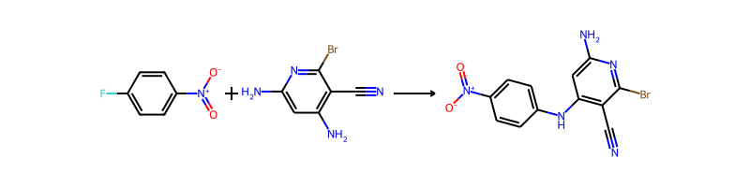

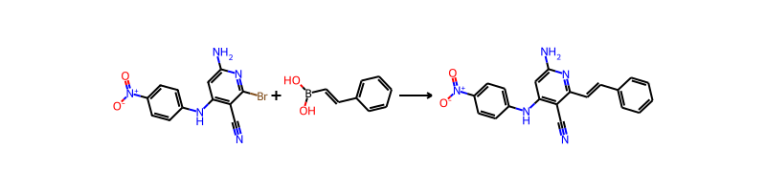

## Product 152

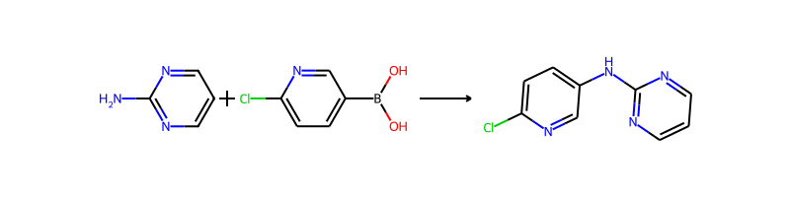

## Product 153

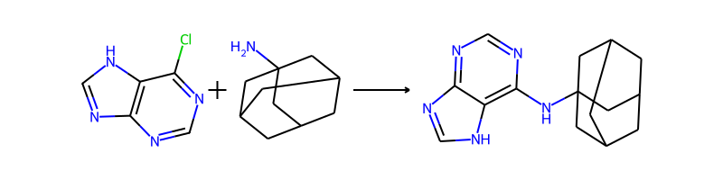

## Product 154

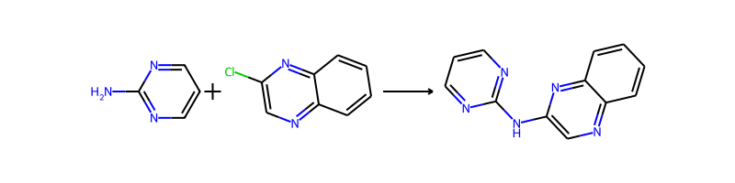

## Product 155

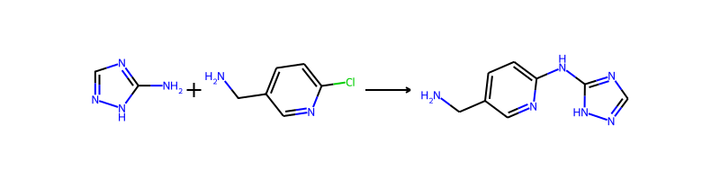

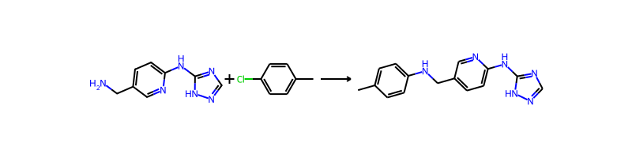

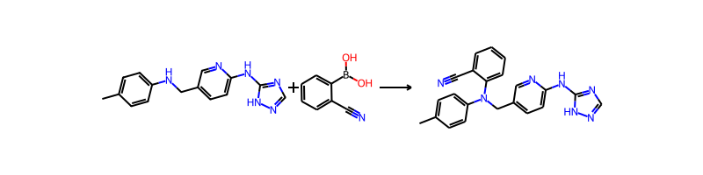

## Product 156

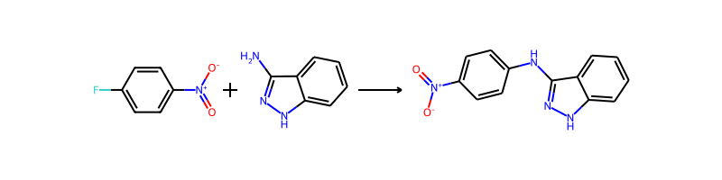

## Product 157

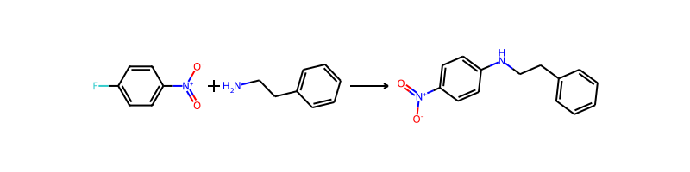

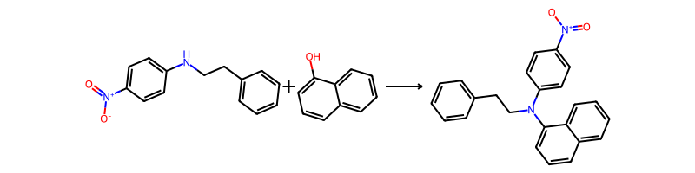

## Product 158



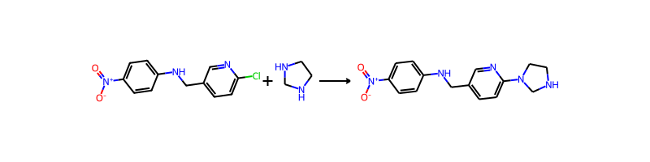

## Product 159



## Product 160

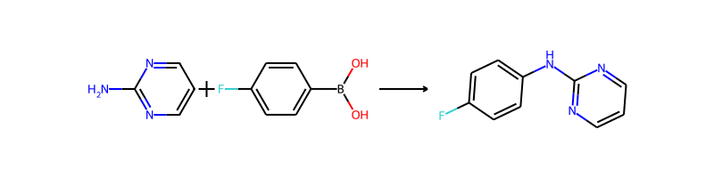

## Product 161

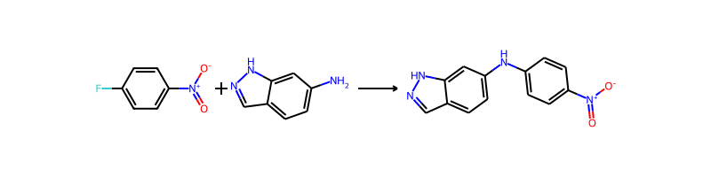

## Product 162

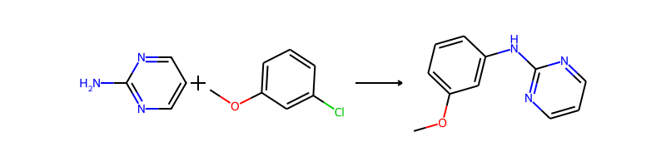

## Product 163

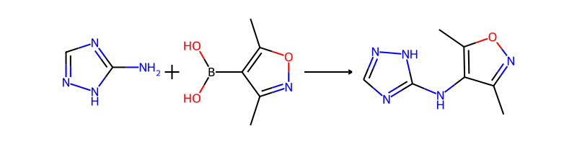

## Product 164

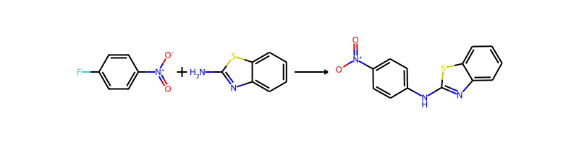

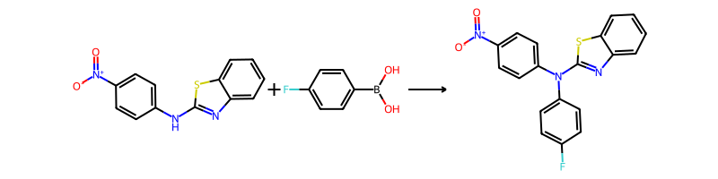

## Product 165

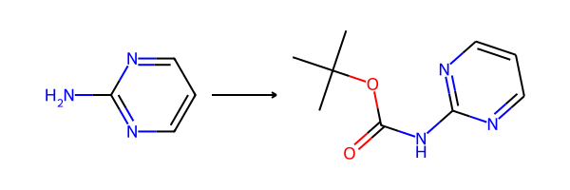

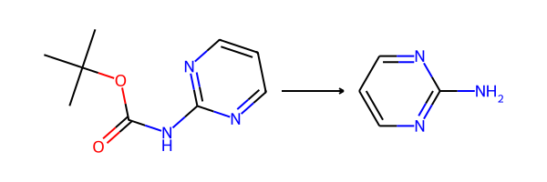

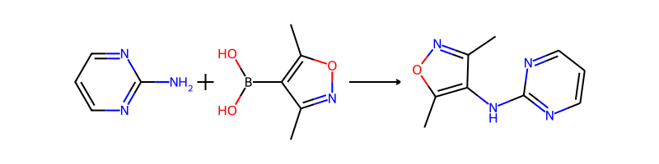

## Product 166

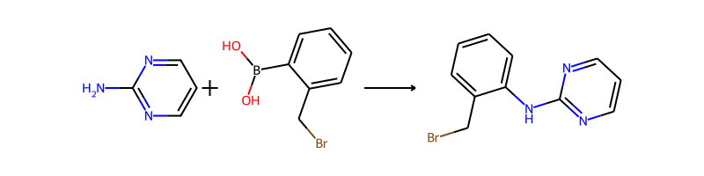

## Product 167

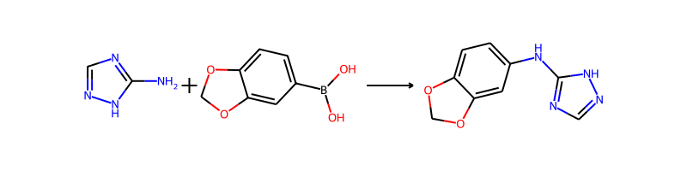

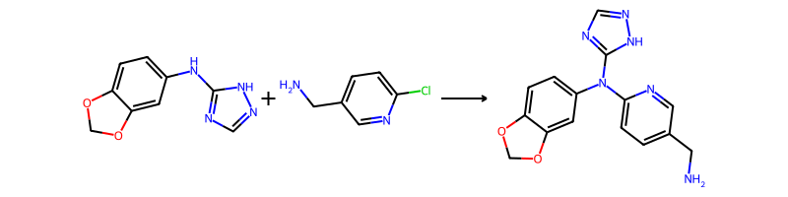

## Product 168

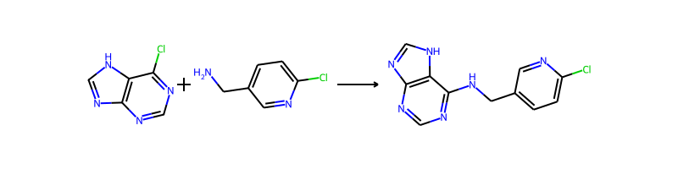

## Product 169

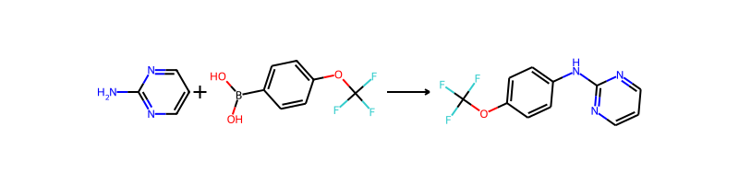

## Product 170

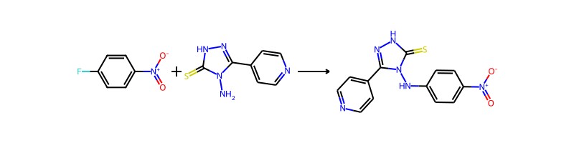

## Product 171

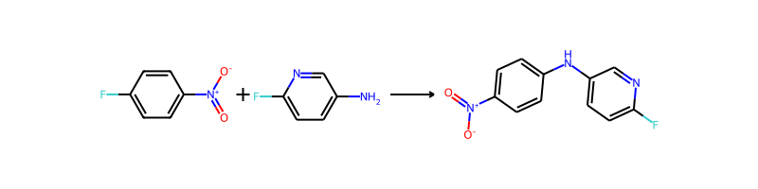

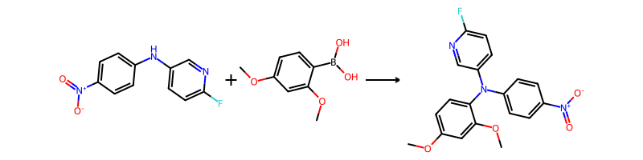

## Product 172

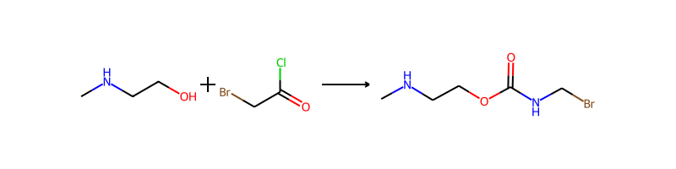

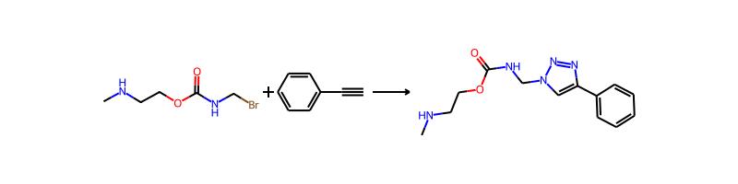

## Product 173

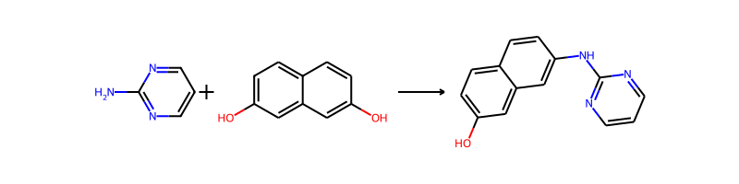

## Product 174



## Product 175



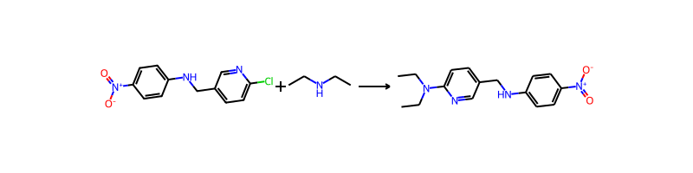

## Product 176

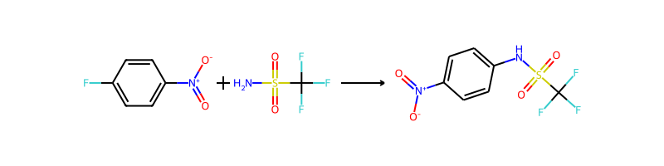

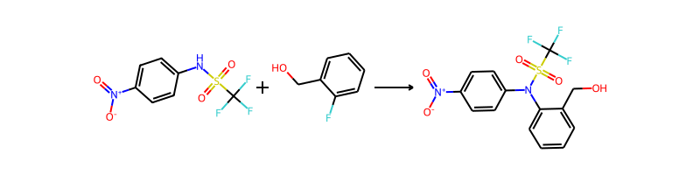

## Product 177



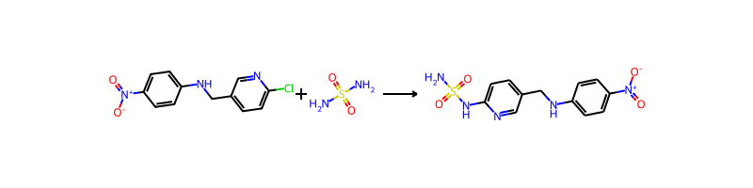

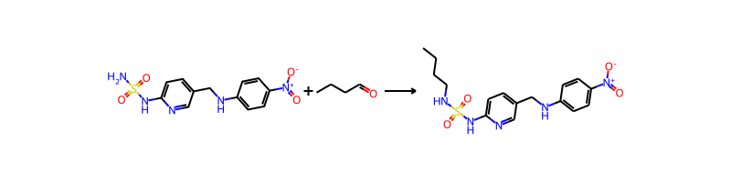

## Product 178

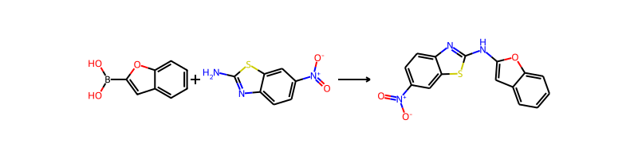

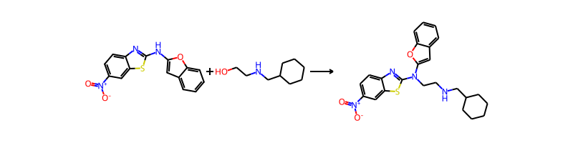

## Product 179



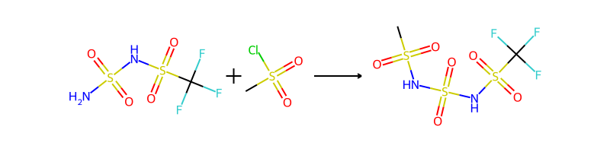

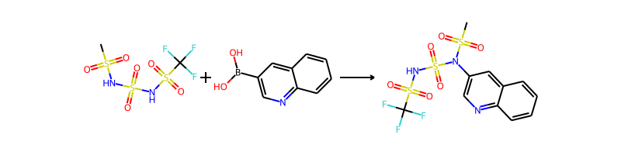

## Product 180

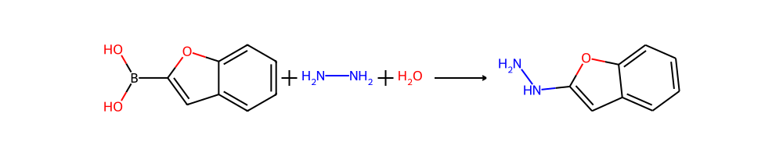

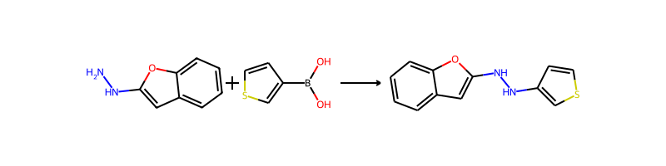

## Product 181

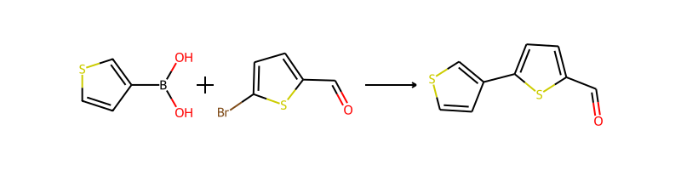

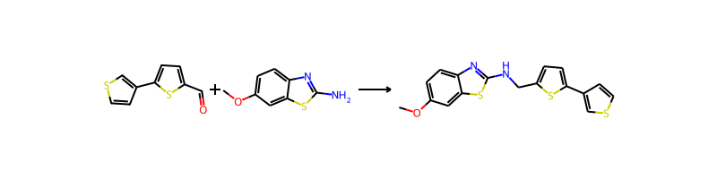

## Product 182

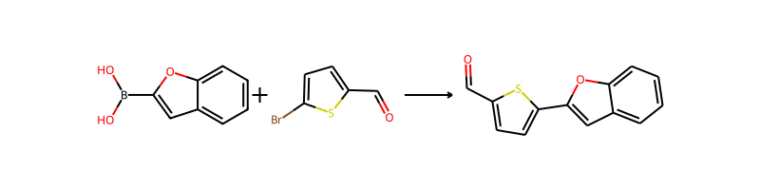

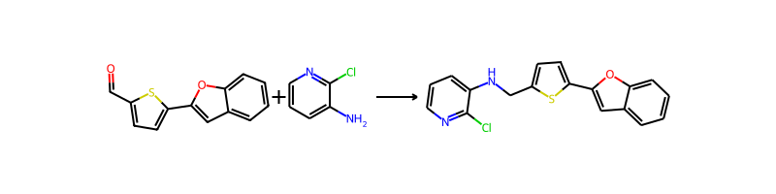

## Product 183



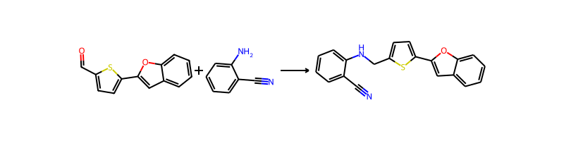

## Product 184

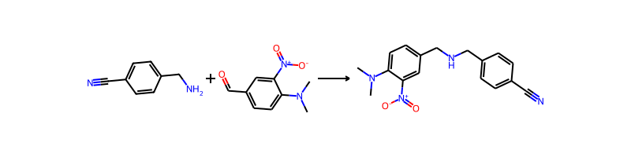

## Product 185

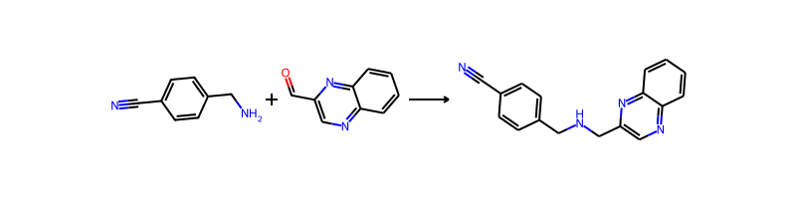

## Product 186

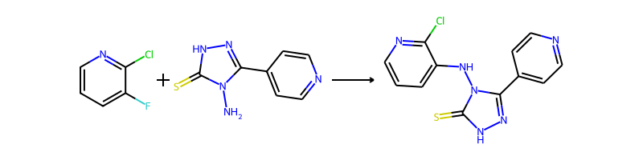

## Product 187

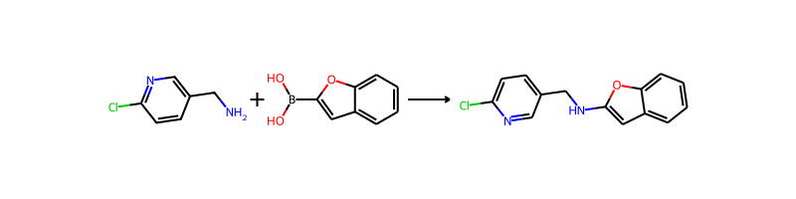

## Product 188

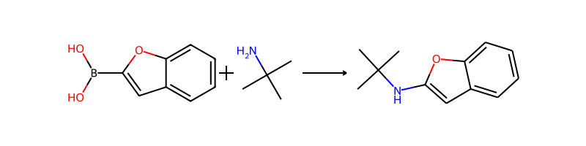

## Product 189

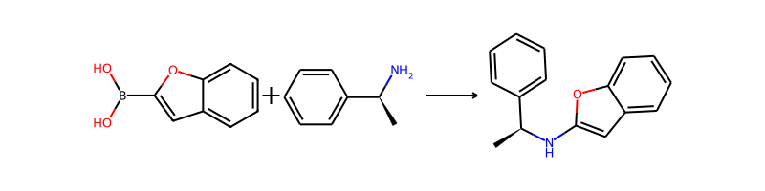

## Product 190

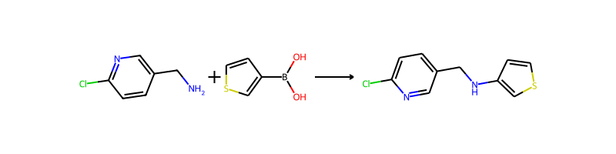

## Product 191

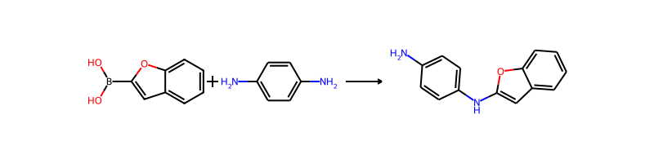

## Product 192

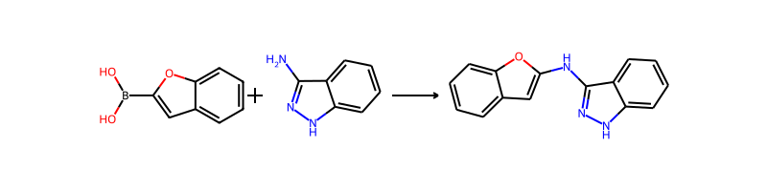

## Product 193



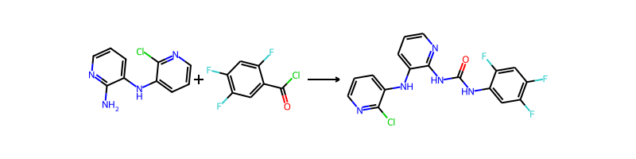

## Product 194

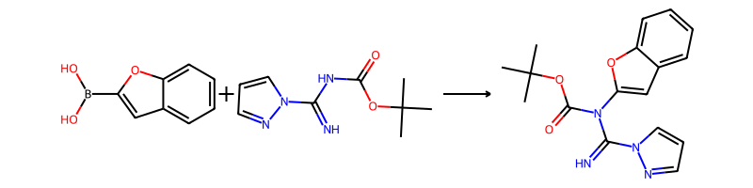

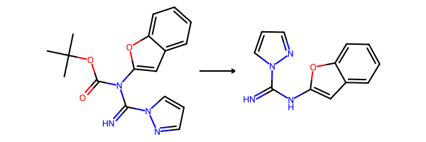

## Product 195

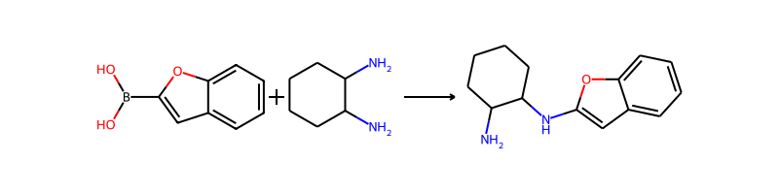

## Product 196

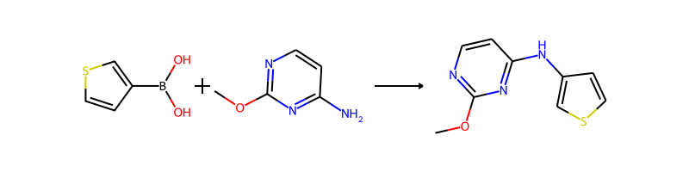

## Product 197



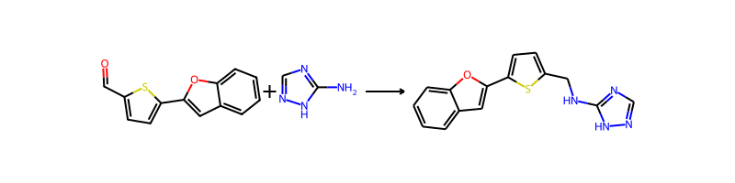

## Product 198

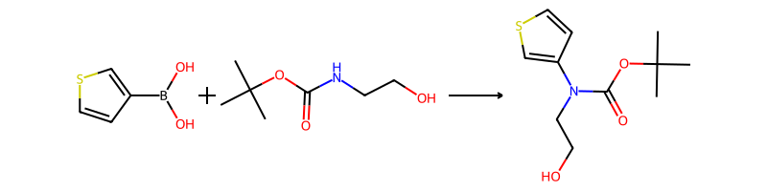

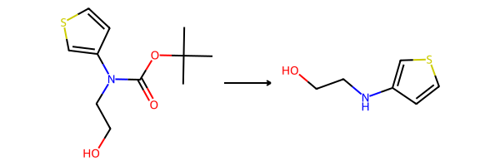

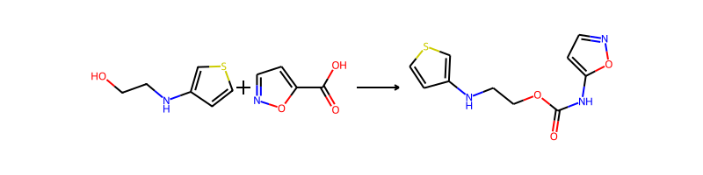

## Product 199

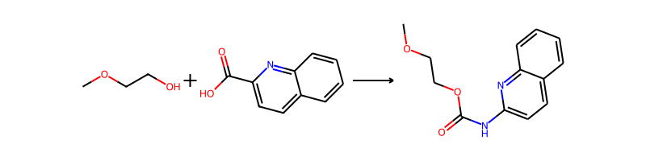

## Product 200

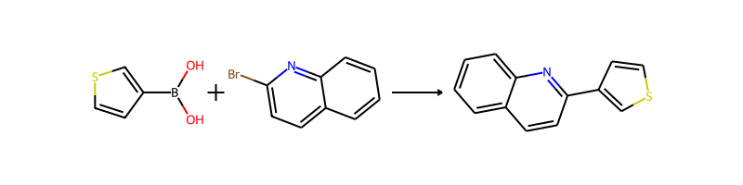

## Product 201

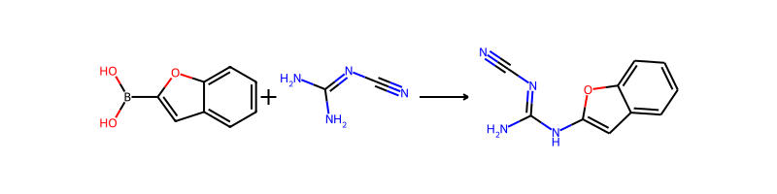

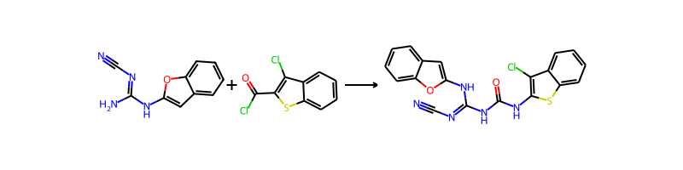

## Product 202



## Product 203

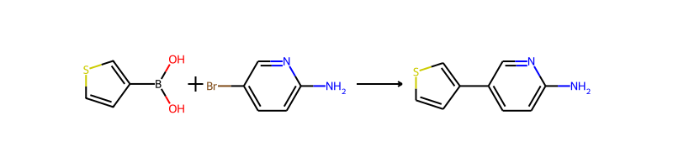

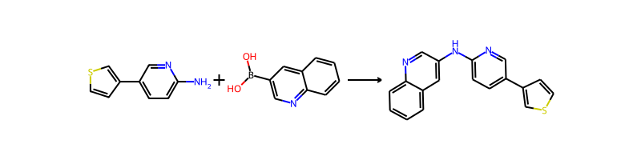

## Product 204

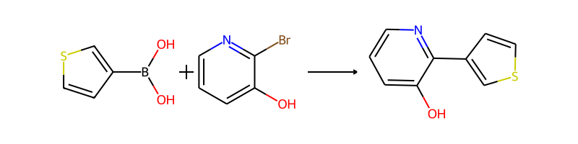

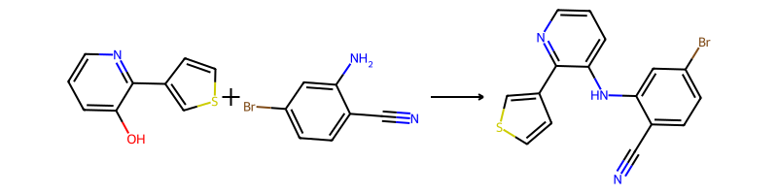

## Product 205

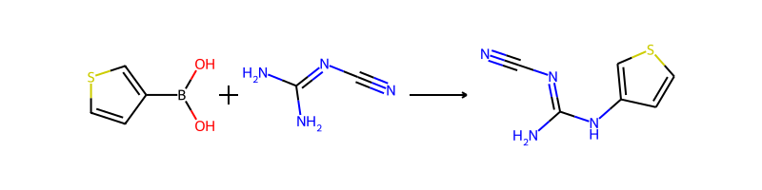

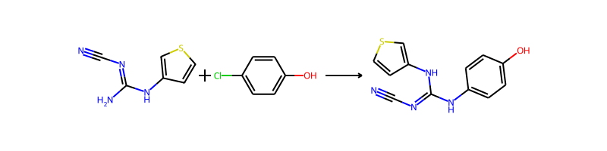

## Product 206



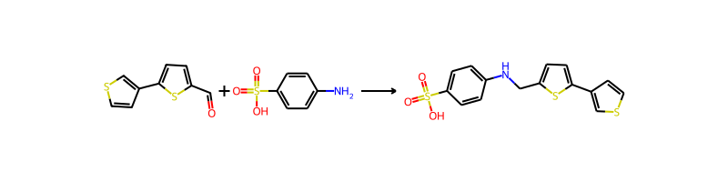

## Product 207

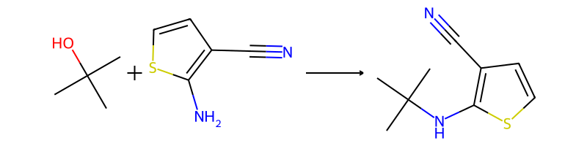

## Product 208

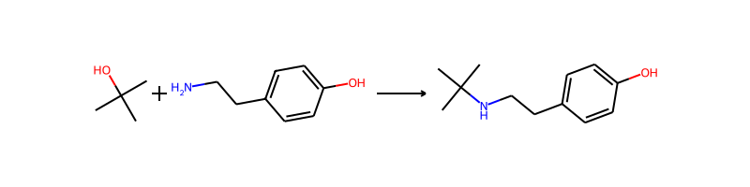

## Product 209

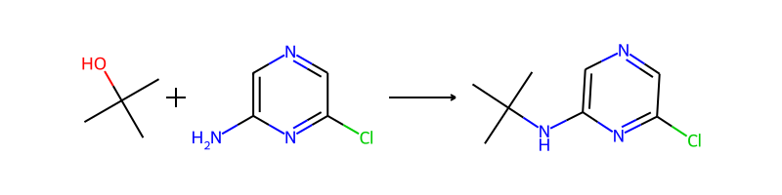

## Product 210

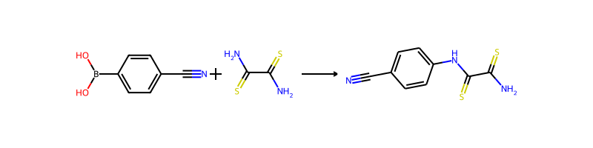

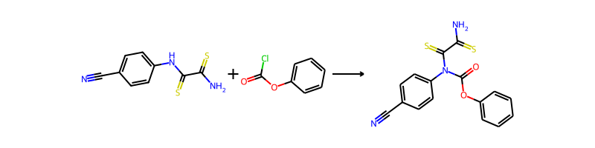

## Product 211

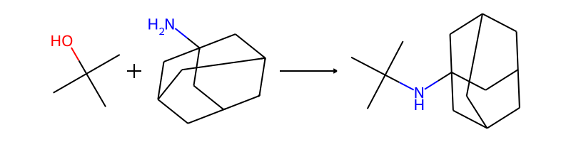

## Product 212

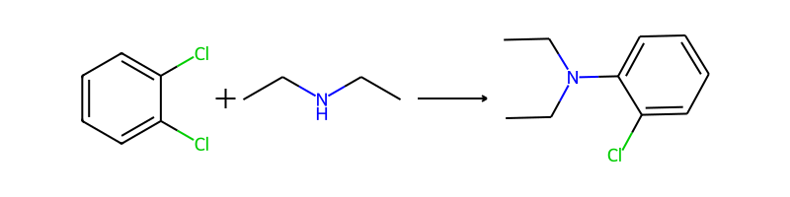

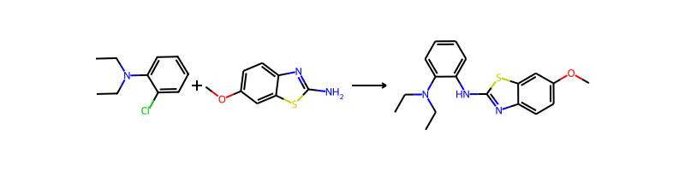

## Product 213

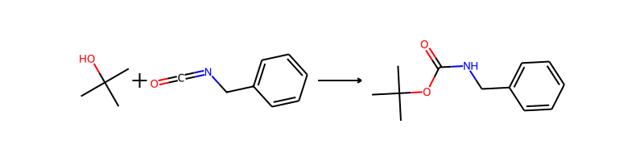

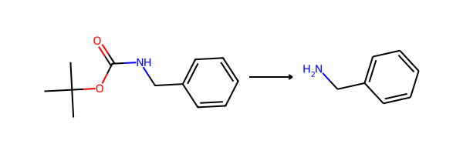

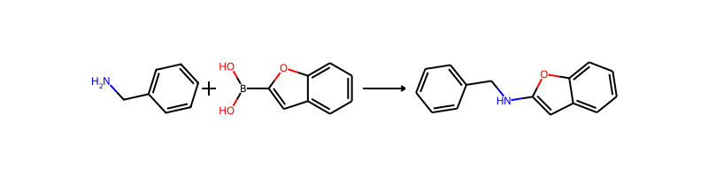

## Product 214

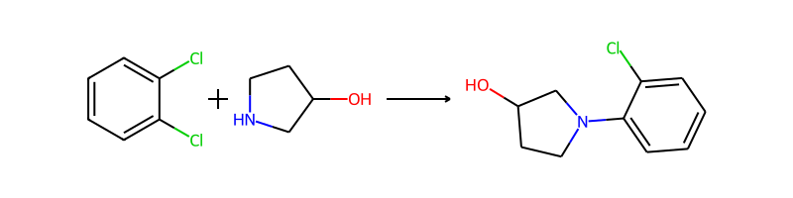

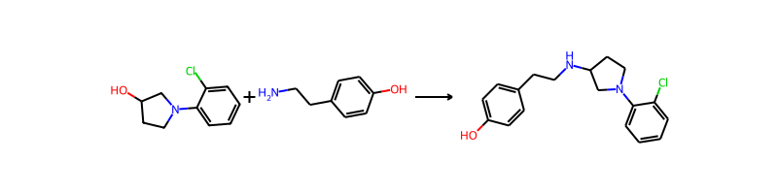

## Product 215

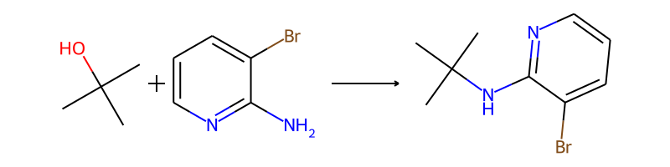

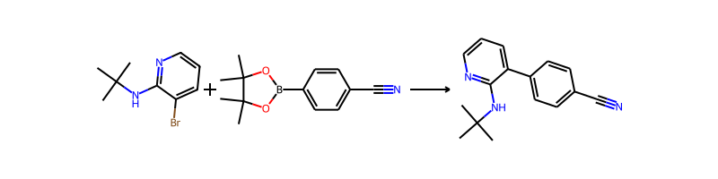

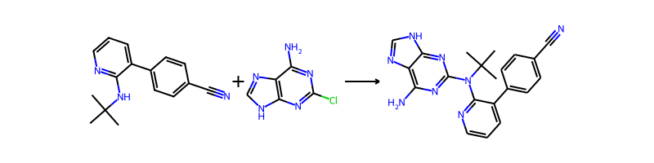

## Product 216



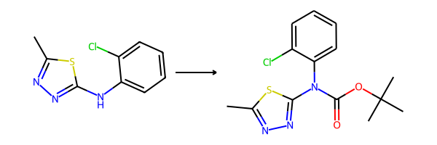

## Product 217

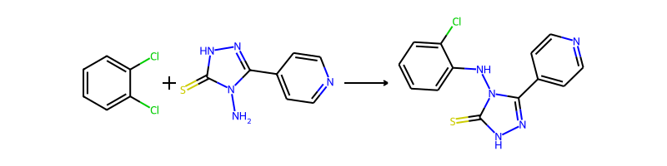

## Product 218

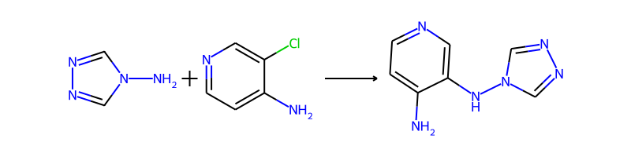

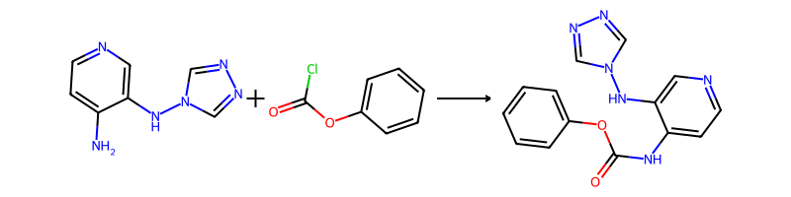

## Product 219

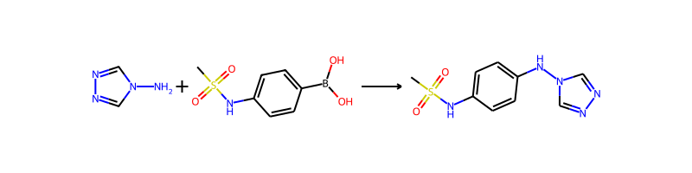

## Product 220



## Product 221

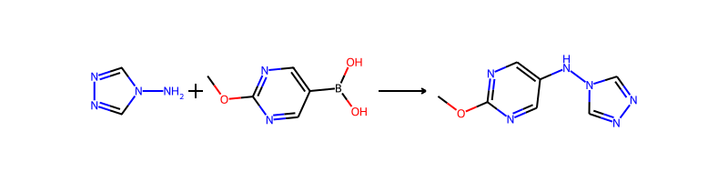

## Product 222

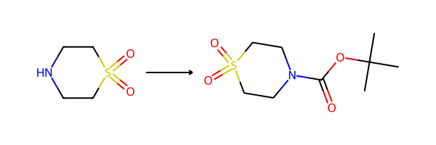

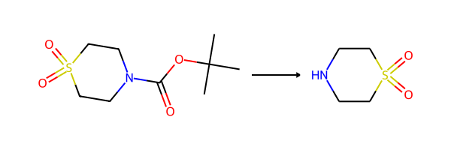

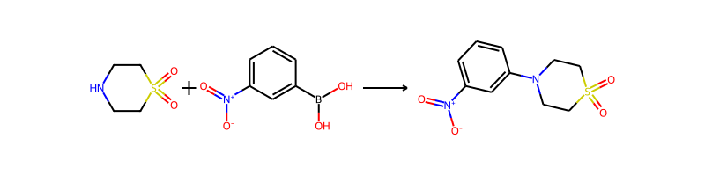

## Product 223

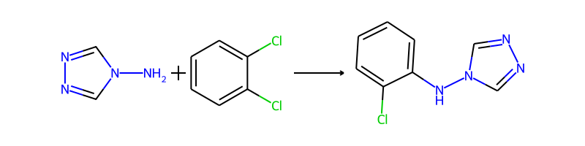

## Product 224



## Product 225

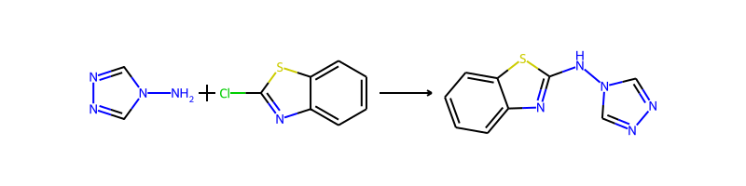

## Product 226

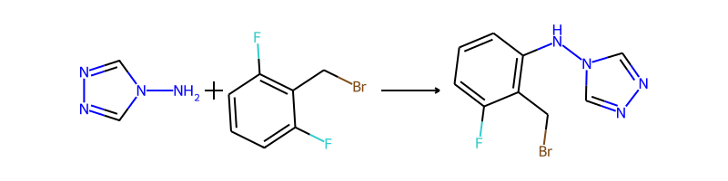

## Product 227

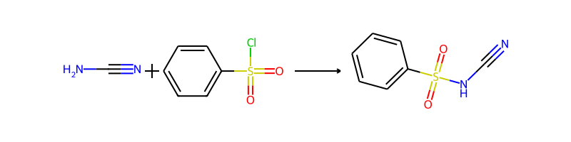

## Product 228

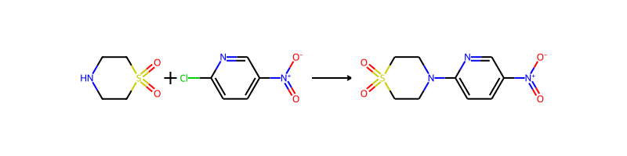

## Product 229

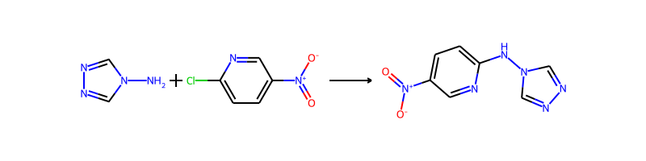

## Product 230



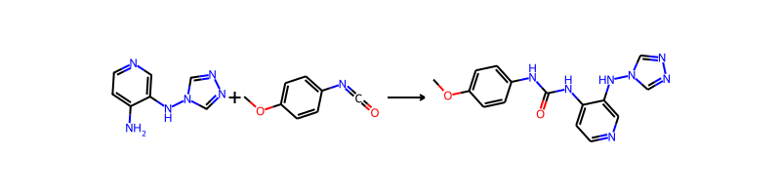

## Product 231



## Product 232

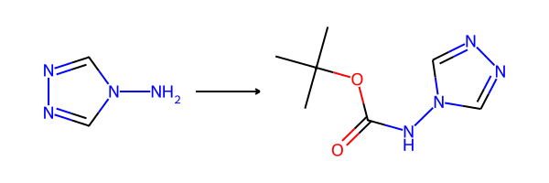

## Product 233

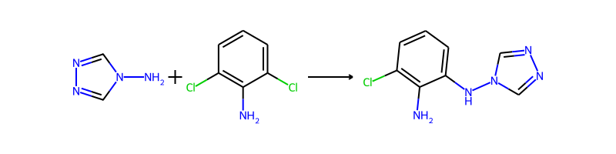

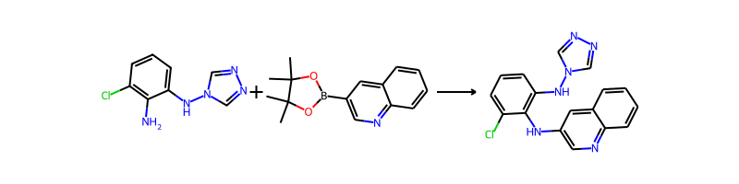

## Product 234

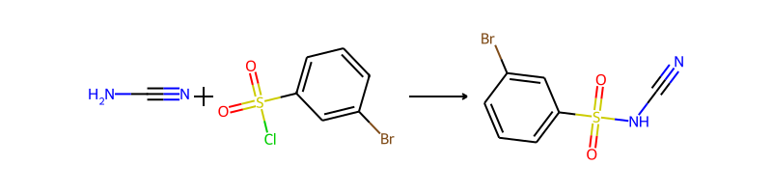

## Product 235



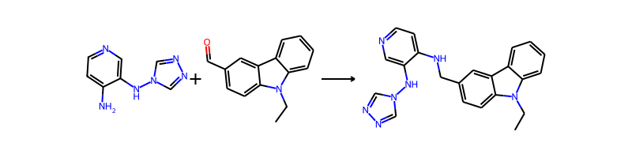

## Product 236

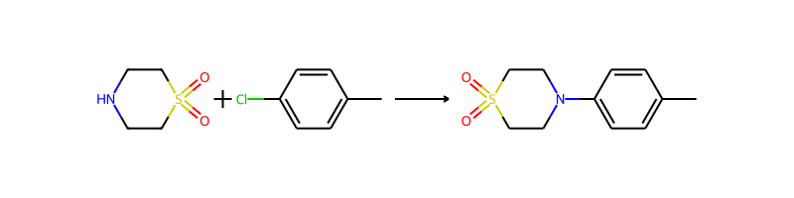

## Product 237

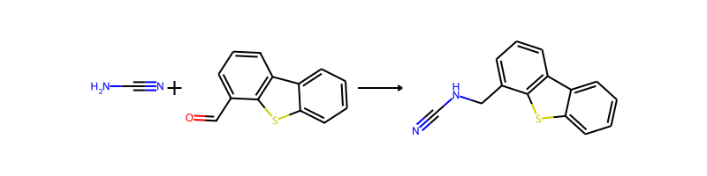

## Product 238



## Product 239

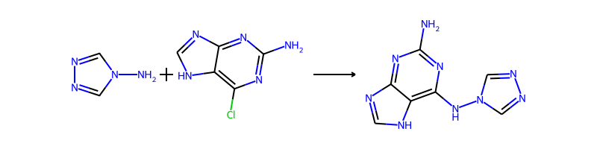

## Product 240



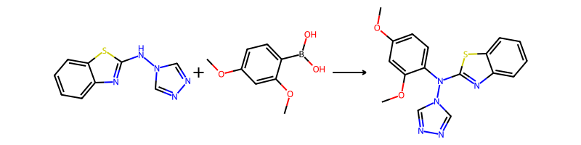

## Product 241



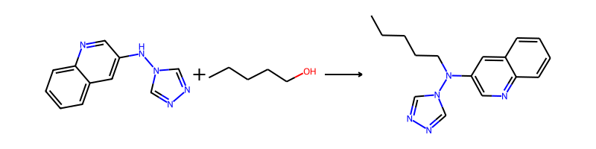

## Product 242



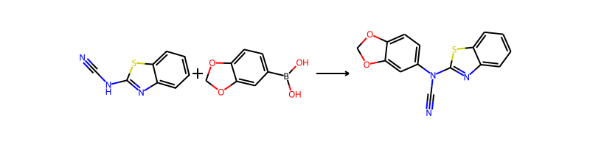

## Product 243

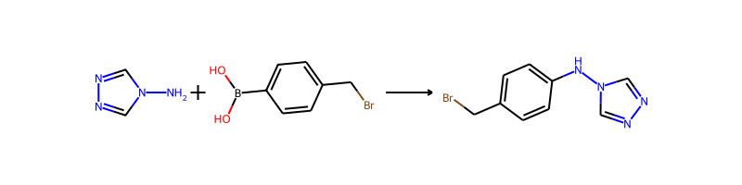

## Product 244

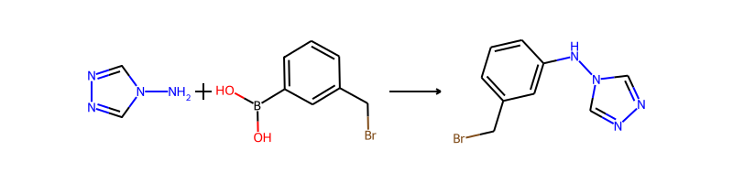

## Product 245



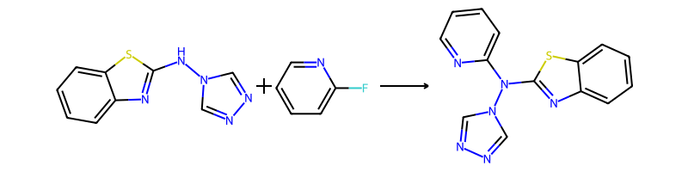

## Product 246

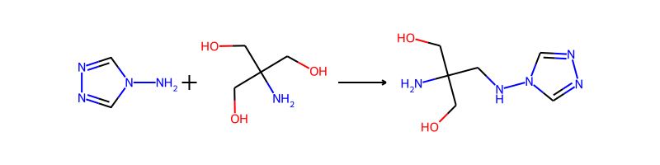

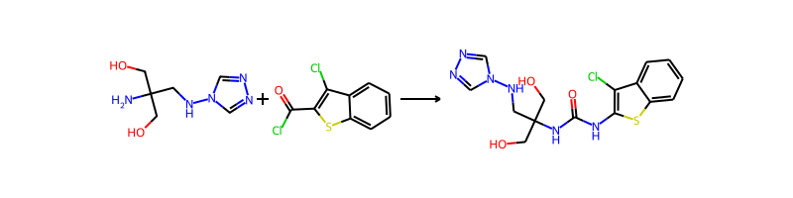

## Product 247

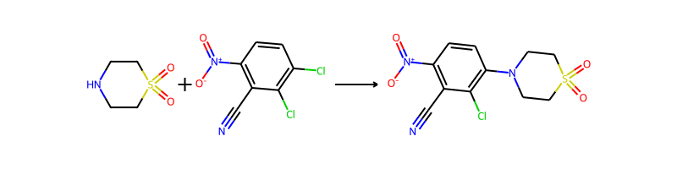

## Product 248



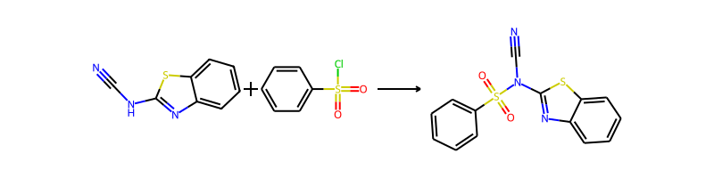

## Product 249





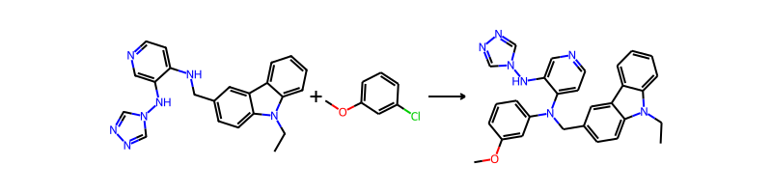

## Product 250



## Product 251

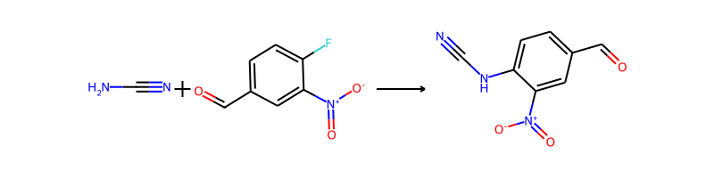

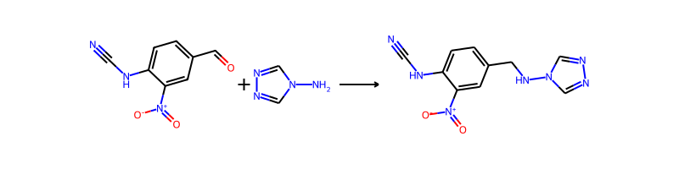

## Product 252

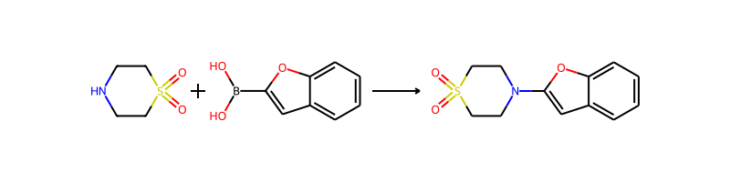

## Product 253



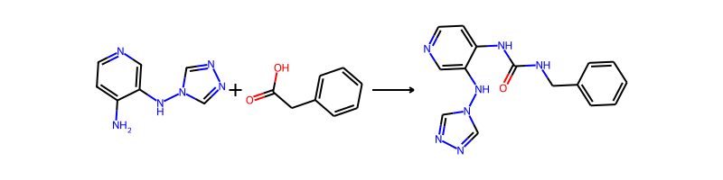

## Product 254



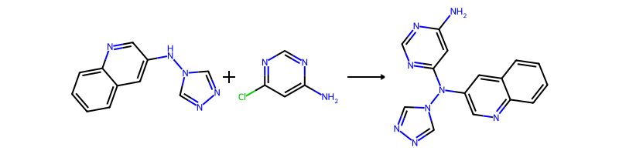

## Product 255



## Product 256



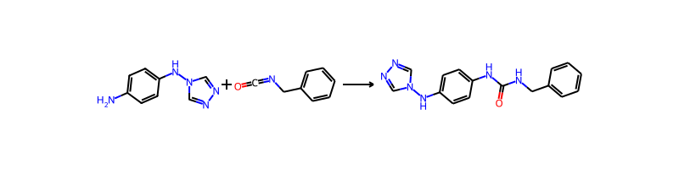

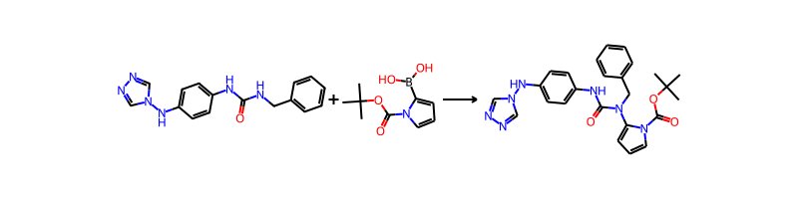

## Product 257

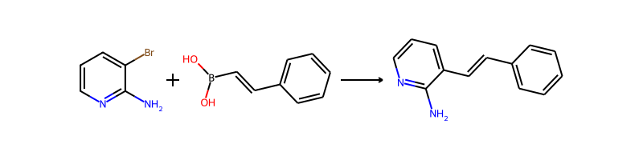

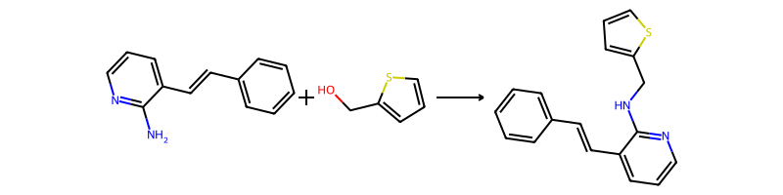

## Product 258

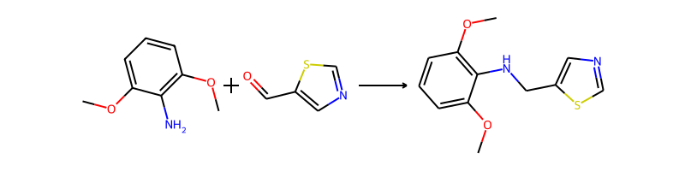

## Product 259

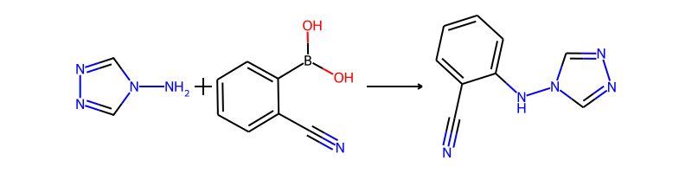

## Product 260

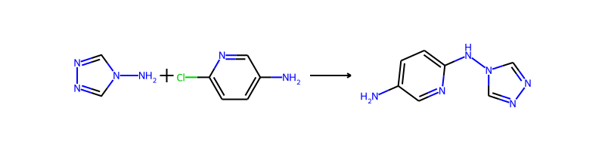

## Product 261



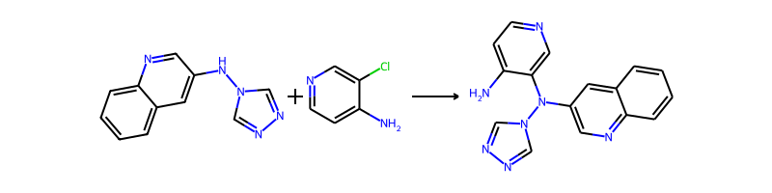

## Product 262

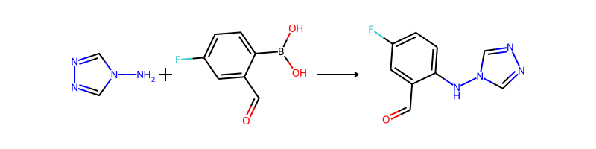

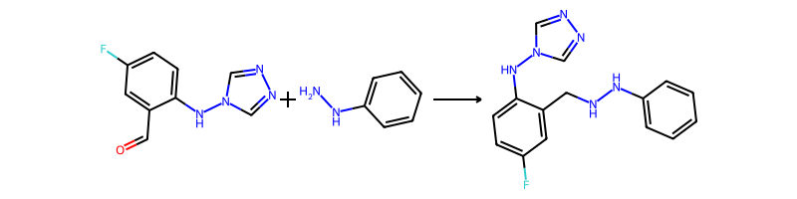

## Product 263



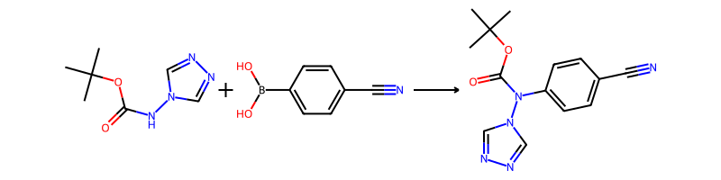

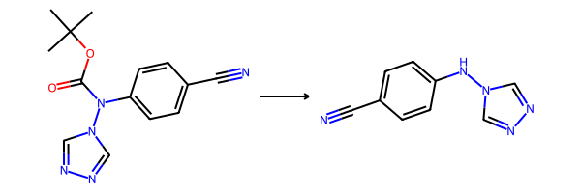

## Product 264

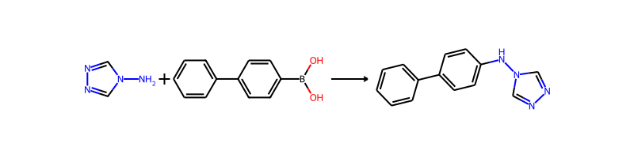

## Product 265

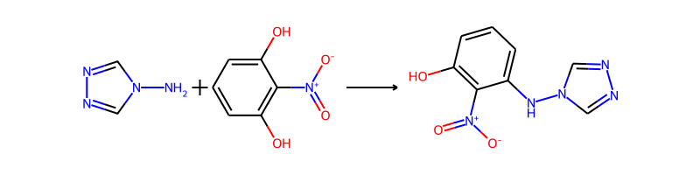

## Product 266



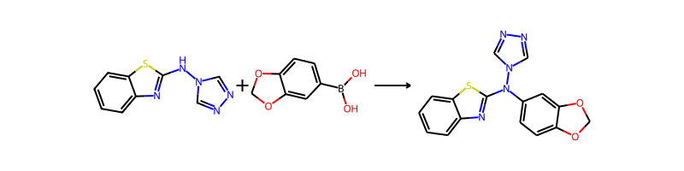

## Product 267



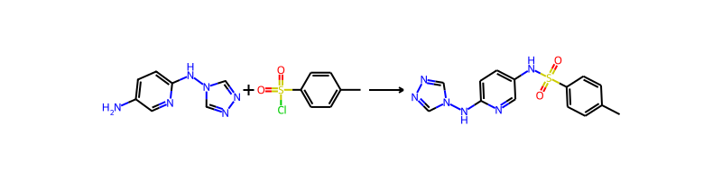

## Product 268

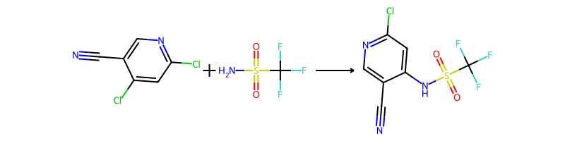

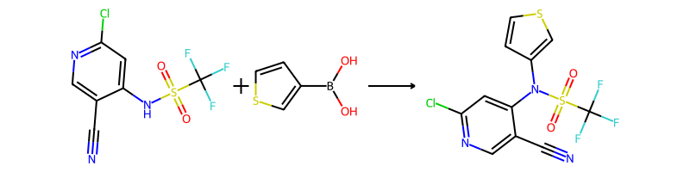

## Product 269

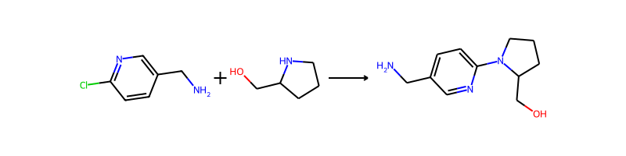

## Product 270

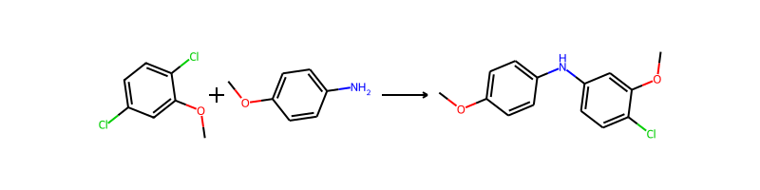

## Product 271

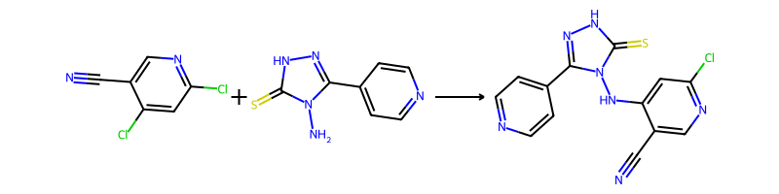

## Product 272



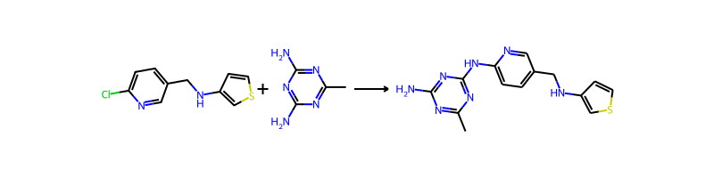

## Product 273

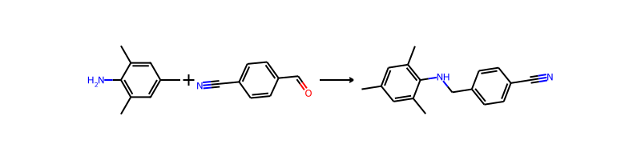

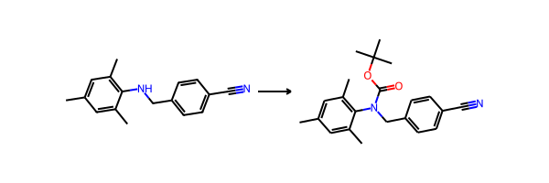

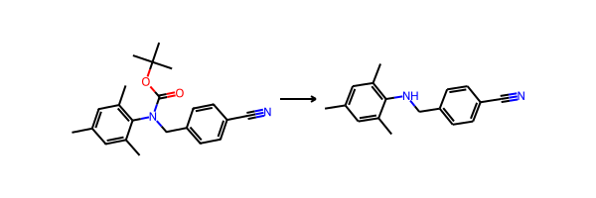

## Product 274

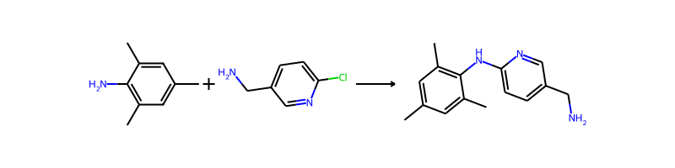

## Product 275



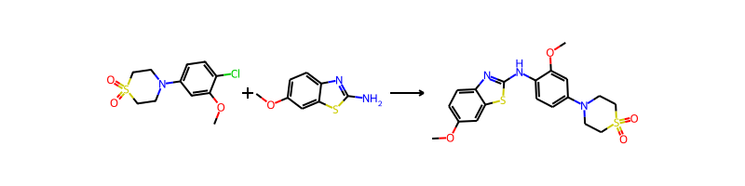

## Product 276



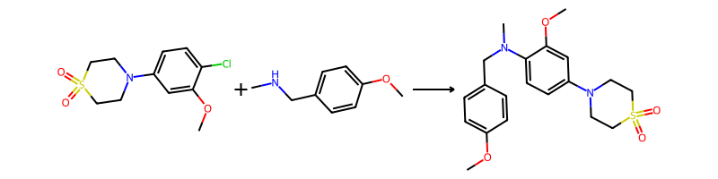

## Product 277

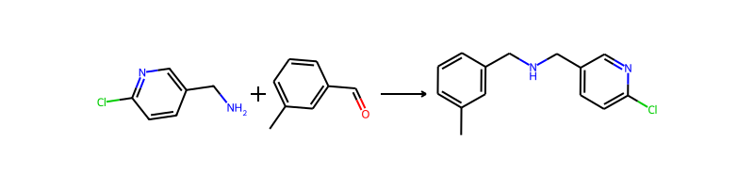

## Product 278



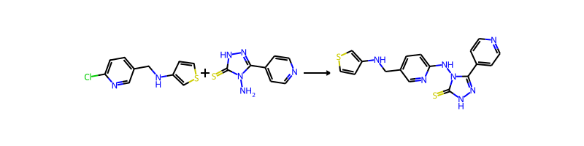

## Product 279

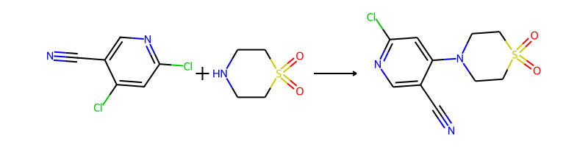

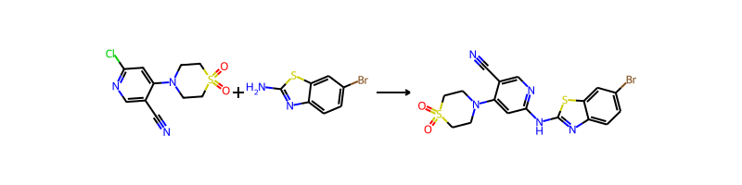

## Product 280





## Product 281

